Analyzing Live Cyber Attacks with Azure Sentinel Lab

By, Victor Patterson Sr

Technical Summary:

This lab I explored the capabilities of Azure Sentinel, a cloud-based Security Information and Event Management (SIEM) solution, in detecting and visualizing live cyber attacks.

Methodology:

1. **Deployment**: A virtual machine (VM) was deployed to act as a honeypot, attracting real-world cyberattacks.
2. **Data Collection:** Azure Sentinel was configured to collect security event logs from the honeypot VM, focusing on Remote Desktop Protocol (RDP) Brute Force attempts.
3. **Live Monitoring:** Real-time attack data was streamed into Azure Sentinel, enabling immediate analysis and response.
4. **Geolocation Analysis**: A custom PowerShell script was developed to extract IP addresses from the attack logs and retrieve their corresponding geolocations using external APIs.
5. **Visualization**: Attack locations were plotted on the interactive Azure Sentinel map, providing a global view of the attack landscape.

**Tools Used:**

Microsoft Azure Sentinel

Azure Virtual Machines

PowerShell scripting

Geolocation API (e.g., IP2Location)

**Outcomes**:

* Successfully established a real-time threat monitoring environment using Azure Sentinel.
* Identified live RDP Brute Force attacks originating from various locations worldwide.
* Visualized the attack landscape on a global map, providing valuable insights into attack patterns and origins.

**Technical Impact**:

This lab demonstrated the effectiveness of Azure Sentinel in proactively detecting and visualizing cyberattacks, empowering security teams with enhanced situational awareness and faster response times.

## Lab Presentation Steps:

**Introduction:**

In this lab, I will explore simulating cyberattacks and visualizing their global reach using Azure Sentinel and PowerShell. I’ll deliberately expose a virtual machine (VM) to attract attacks, then leverage Sentinel's advanced capabilities to track attacker locations on a map.

**Steps:**

1. **Azure Subscription and VM:**
   * **(Already Completed):** I will leverage your existing Azure subscription and portal access. 
   * **VM Configuration:** I will create a VM with **intentional security vulnerabilities** for educational purposes. 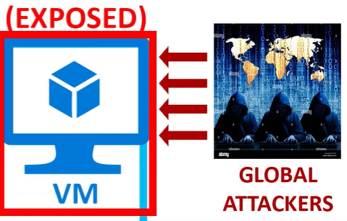
   * 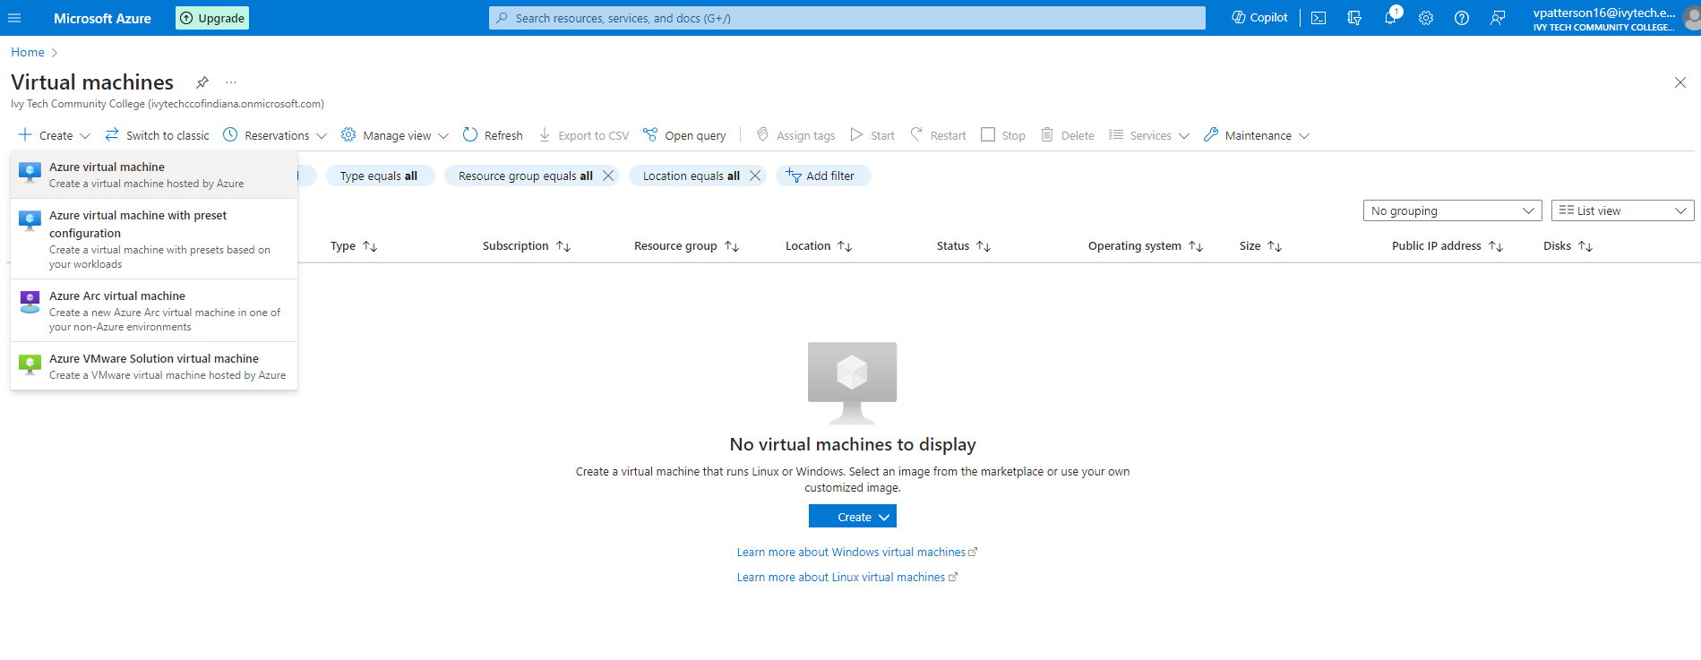
   * 1st Creating the VM with intentional security vulnerabilities. The resource group name is *HoneypotlabV*
   * 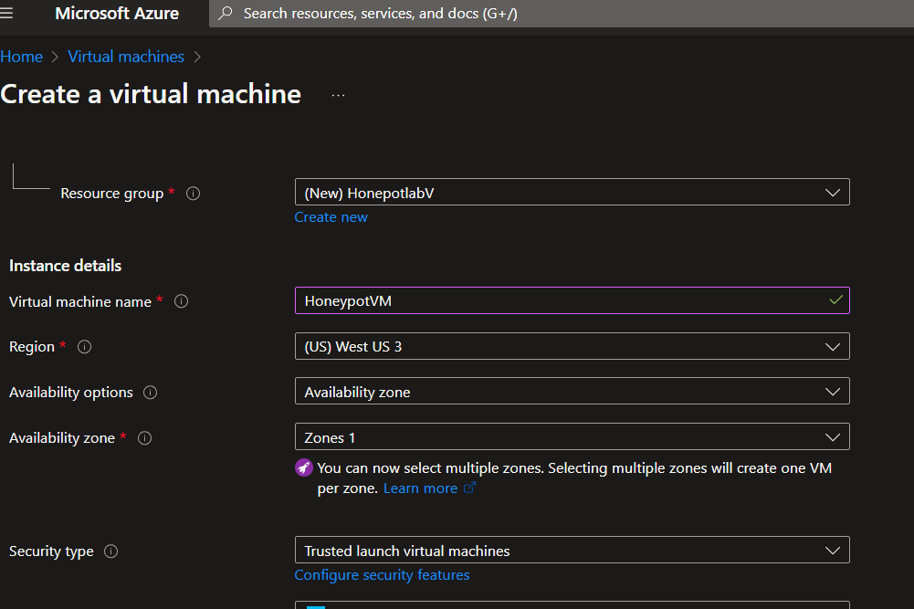
   * For Addmin Account and Lab Purpose I kept this name Simple:
   * Username: **vtechadmin**
   * Password: make up your own: Password####
   * **This includes:**
     + **Disabled external firewall:** This exposes the VM to internet traffic, attracting potential attacks.
     + **Stopped Windows firewall:** I will temporarily disable Windows firewall to observe raw attack attempts.
     + ***Note*:** This is purely for educational purposes and should never be done in a real-world scenario.
     + Within creating my VM I created a new Firewall by selecting the advanced settings under NIC network security group.
     + 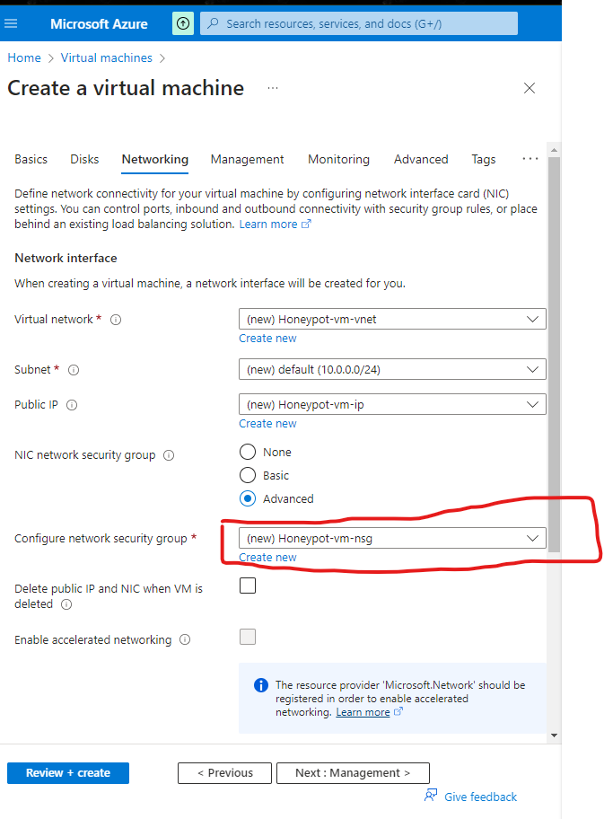
     + 1st deleted the 1000:default-allow-rdp *rule* because its default and I will be creating a new inbound rule that allows everything into the vm so the destination port were gonna put a star for any protocol action allow priority well make it low to 100 and the name I choose -*SMOOTH_CRIMINAL_l*
     + 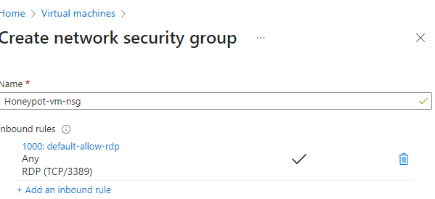
     + 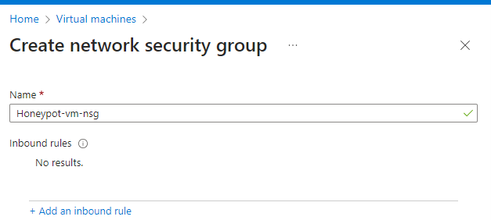
     + In the description below I deleted the destination port ranges in place for Add inbound rule changing the priority to 100. This will essentially allow all traffic from the internet into my VM.
     + 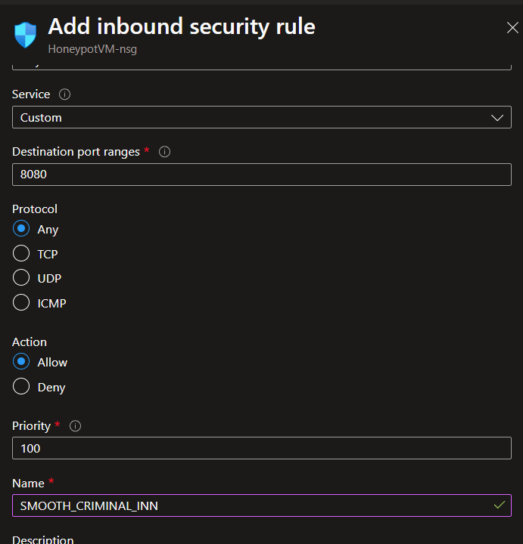
     + This set up was done correctly exposing my VM to the public internet. As shown.
     + 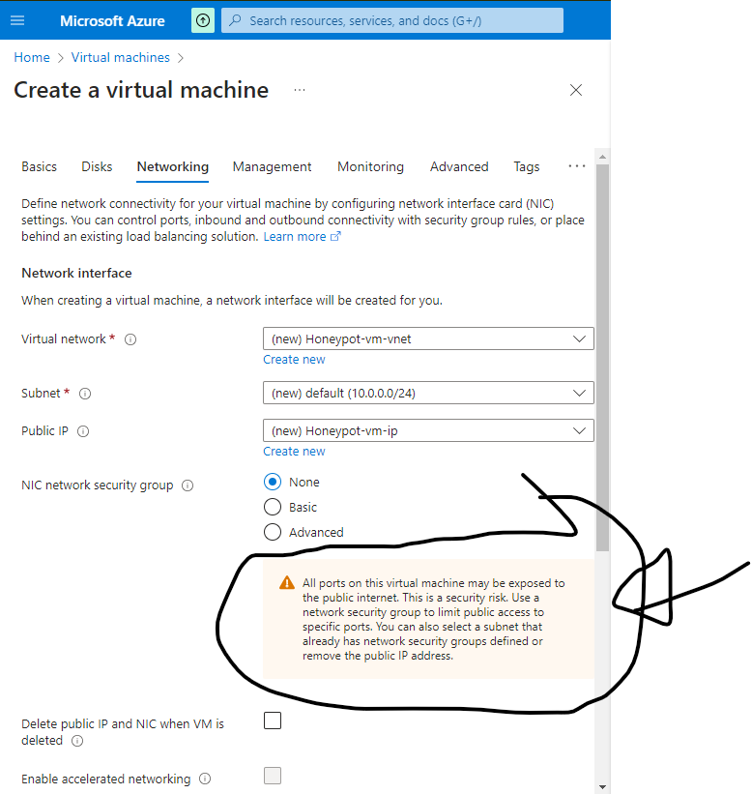
     + After that I clicked review & create.
     + 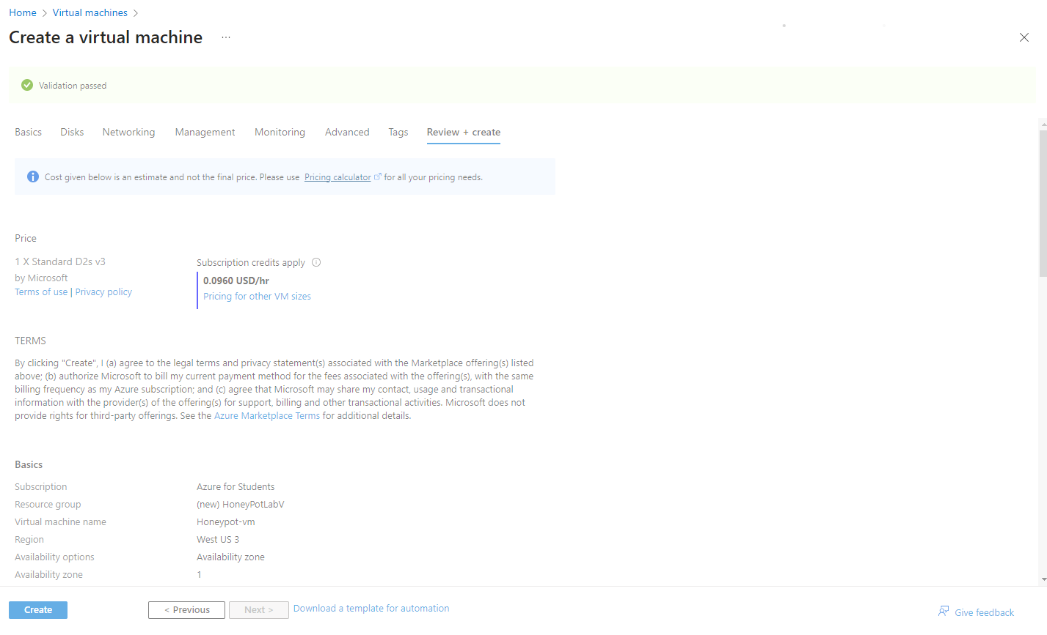
     + 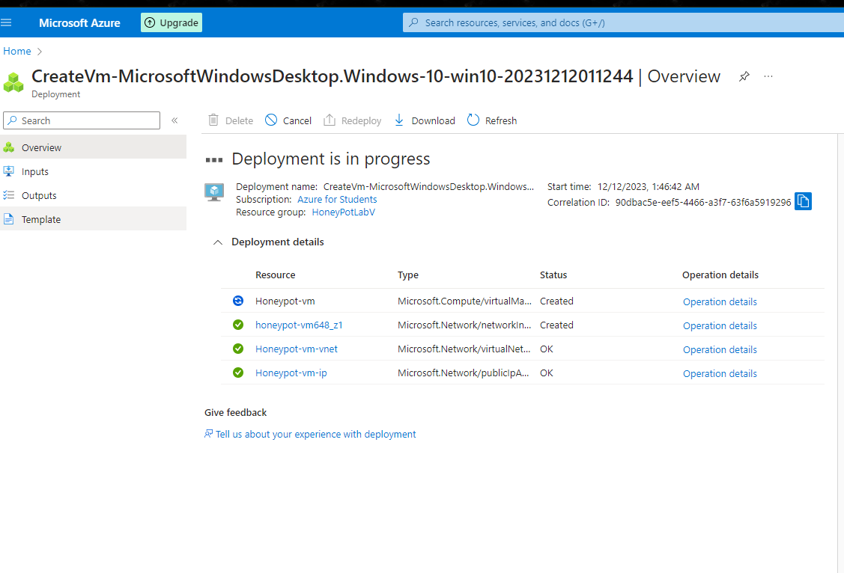
2. **Log Analytics Workspace and Azure Sentinel:**
   * **Log Analytics Workspace:** I created a workspace to store logs from the VM.
   * The purpose of this is to ingest logs from the virtual machine we’re going to ingest the windows event logs. I will be creating my own custom log that contains Geographic information so that I can kind of discover were the attackers are coming from.
   * 
   * 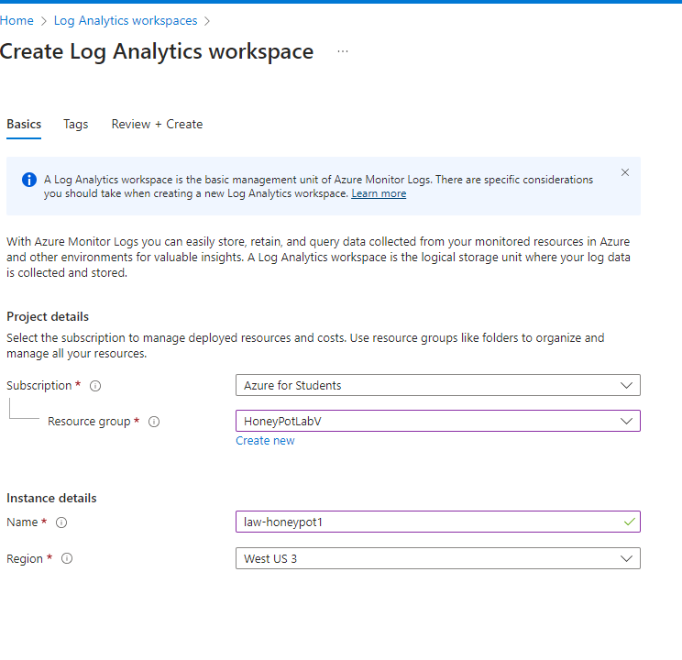
   * 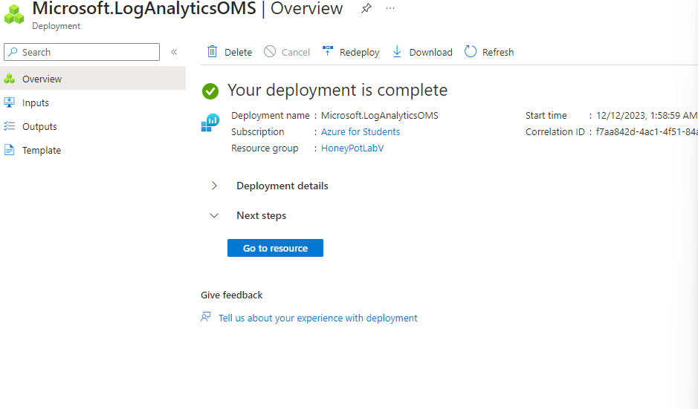

## Microsoft Defender for Cloud Lab Steps:

**Step 1: Azure Defender for Cloud Enrollment and Data Aggregation for Sentinel**

* **Navigate to Microsoft Defender for Cloud within the Azure Portal.**

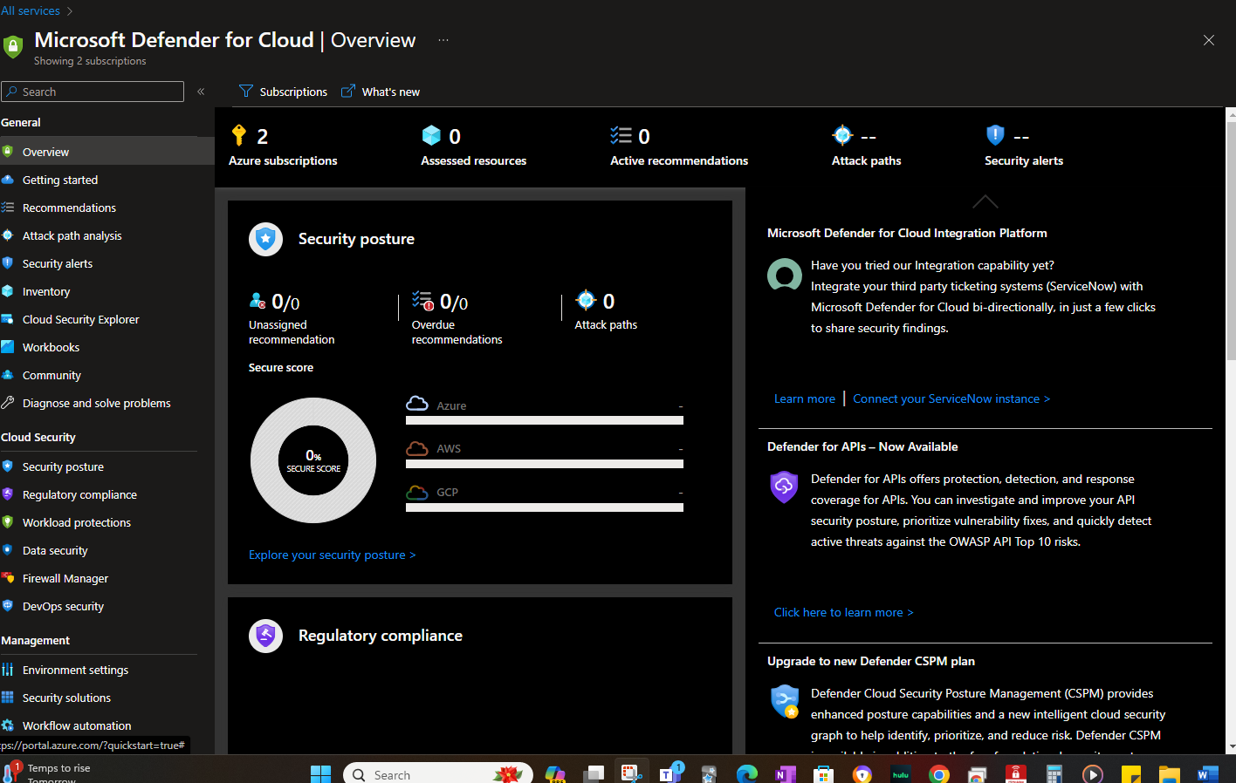

* **Provisioning Plans:**
  + **Select the appropriate subscription and resource group for enrollment.**
  + **Choose the "Foundational CSPM" and "Servers" plans.** These plans offer essential security and compliance monitoring for my Azure resources, including my **HoneyPot-VM**.
  + 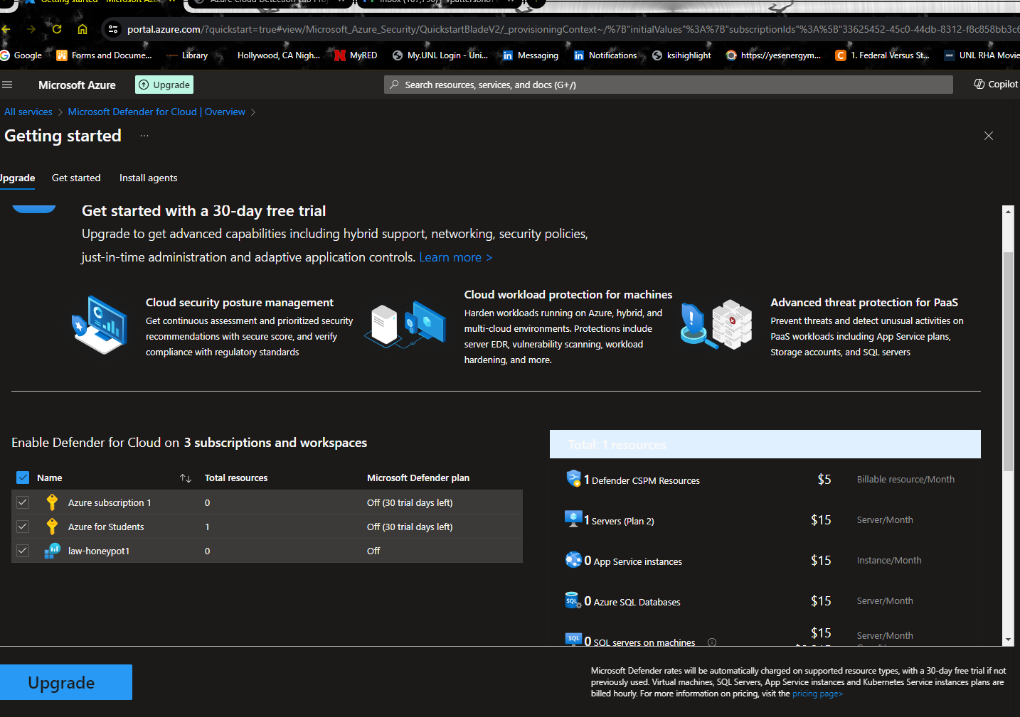
  + 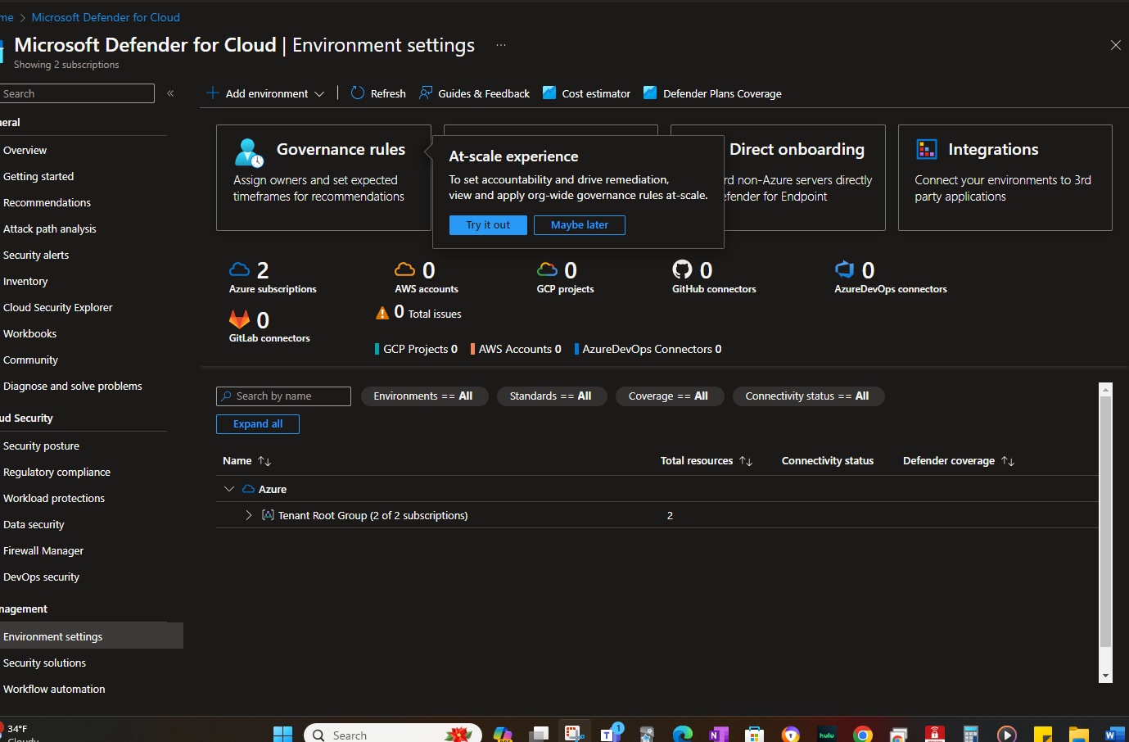
  + 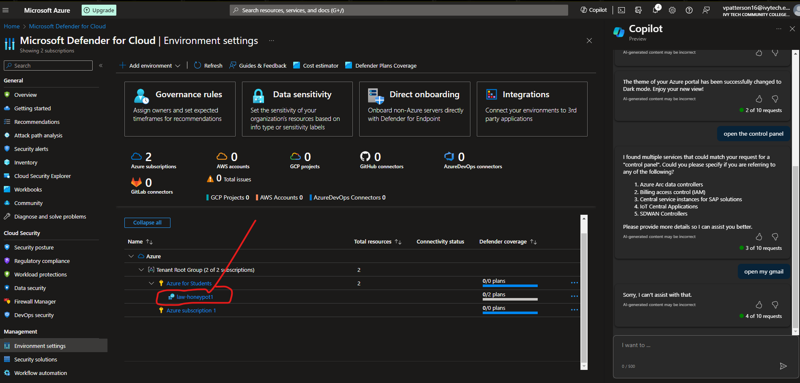
  + 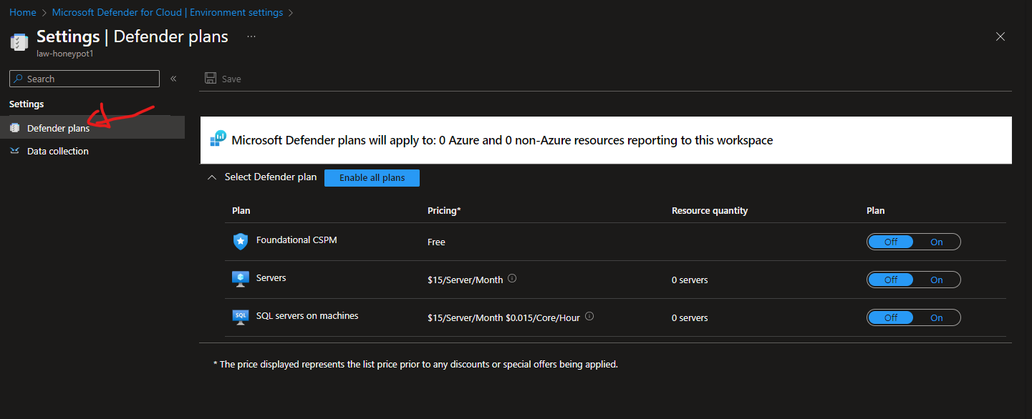
  + 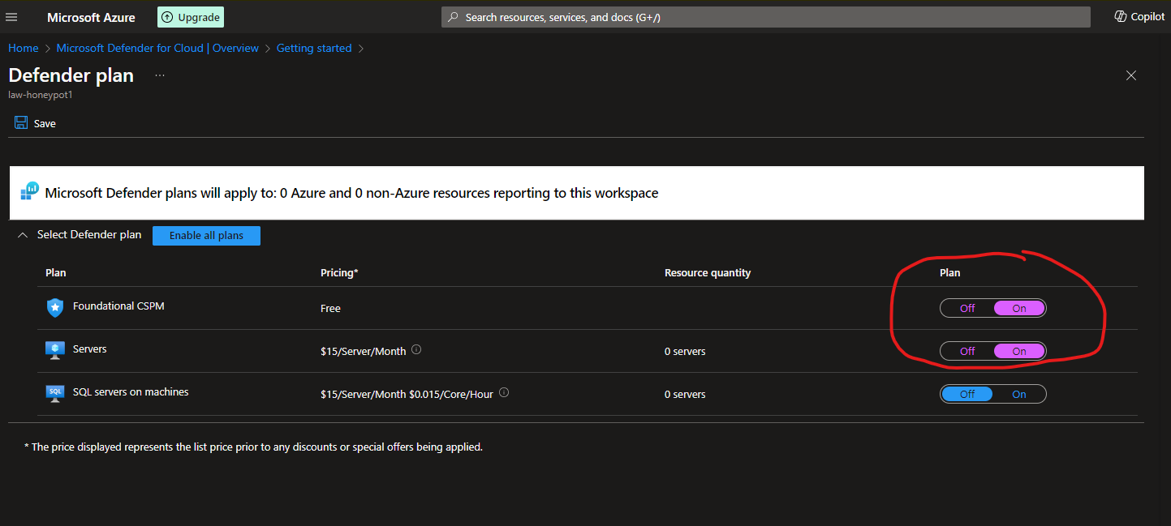
  + **Select Foundational & Severs and Save**
  + 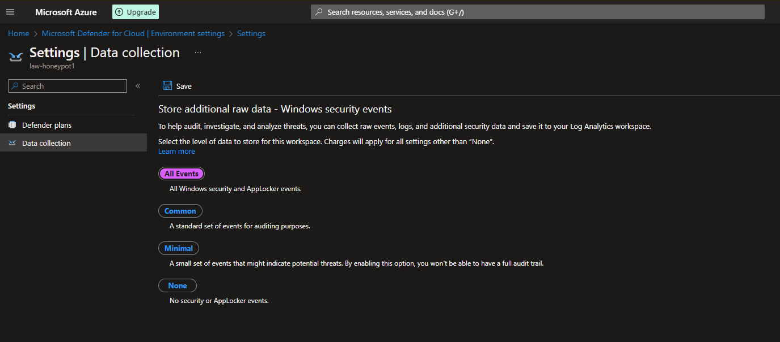
  + **Selected “All Events” and save**
  + **Next Traveled back to Log Analytics workspace.**
  + **Selected my honeypot VM**
  + 
  + **Next with my Log analytics that will look like this below**
  + 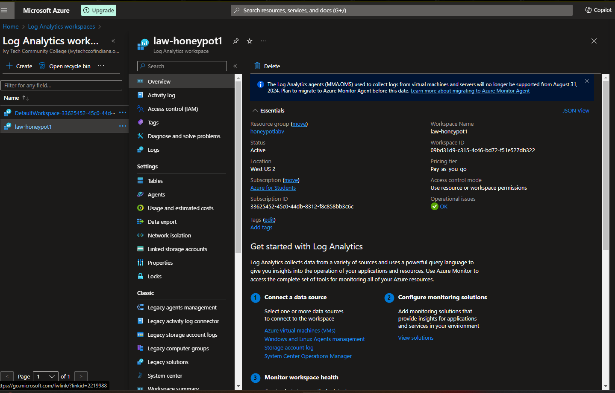
  + Within the Log Analytics workspace located on the left hand side of the of the screen I located and selected my VM 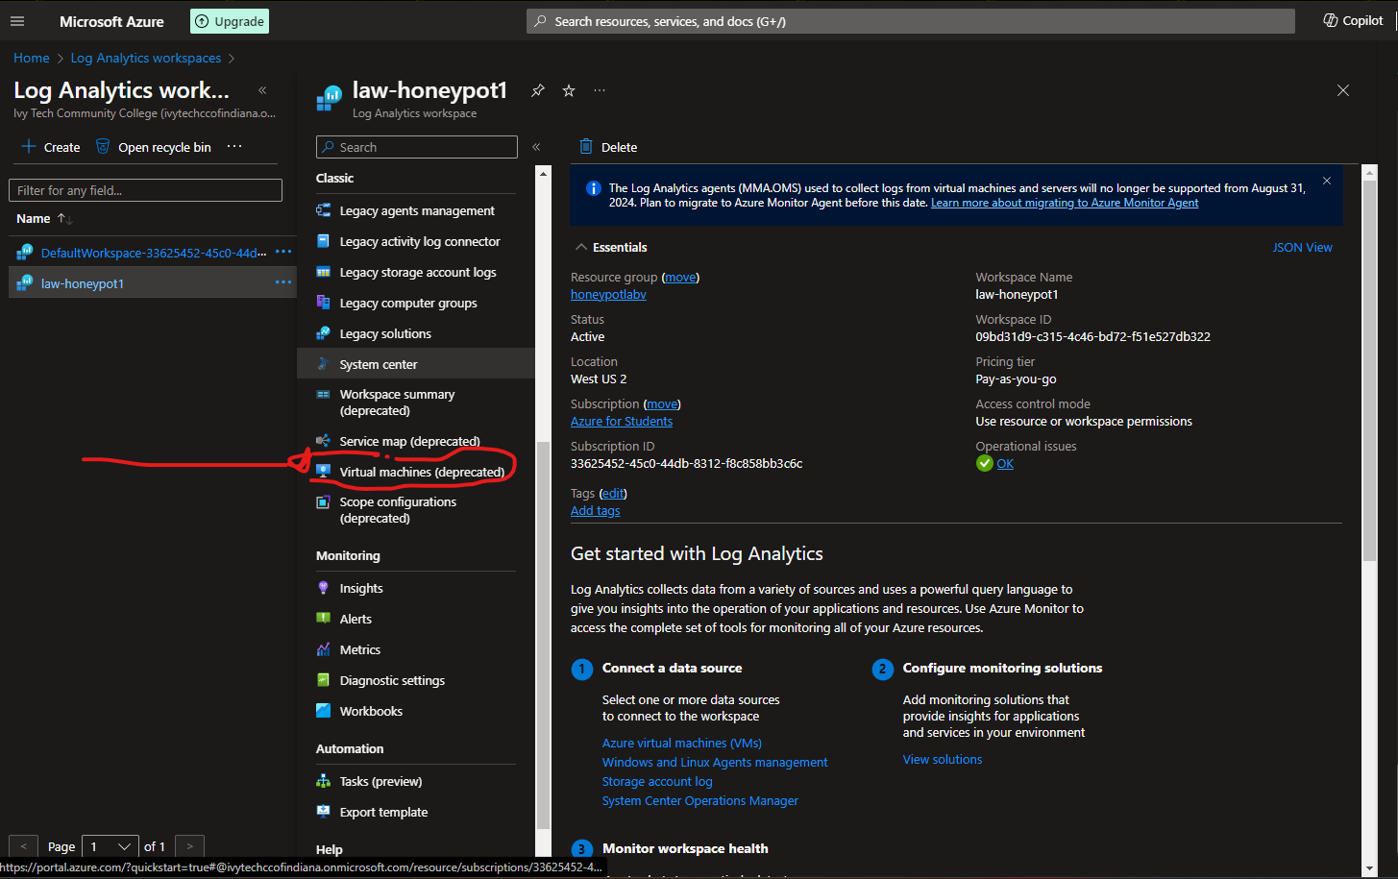
* **Selected the Honey pot VM as shown.**
* 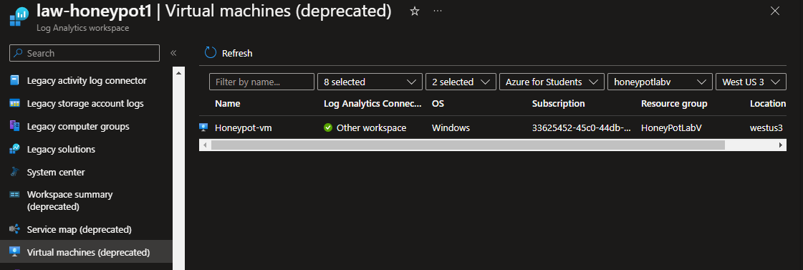
* **Make sure once opened and selected that I turned on my connector.**
* **Next from the searched for Sentinel to install:**
* 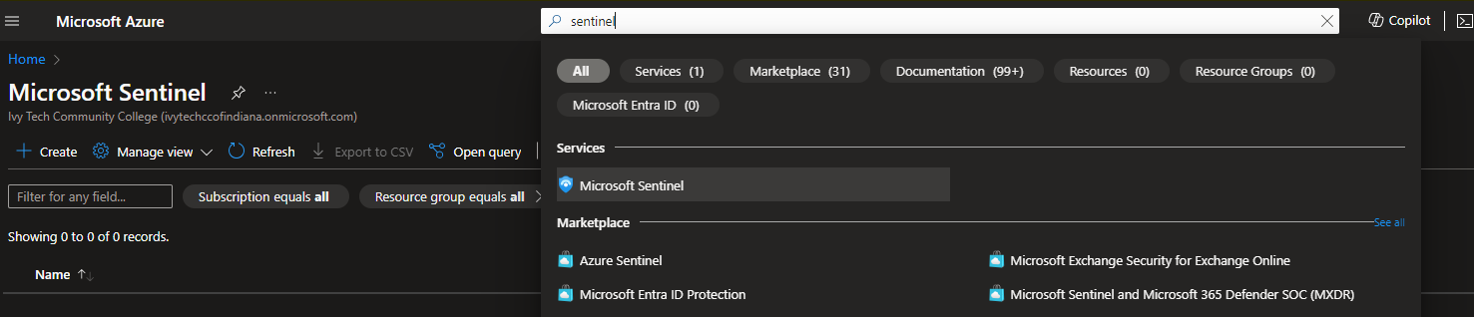
* **Choose the selective log Analytics workspace.**
* 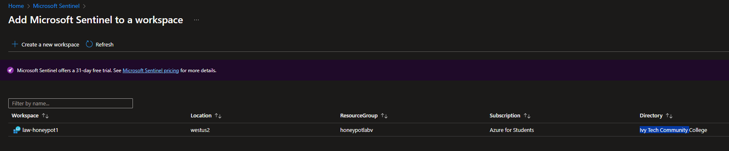

While installing I navigated back to my VM and copied my ip address as shown.

**IP 20.163.31.144**

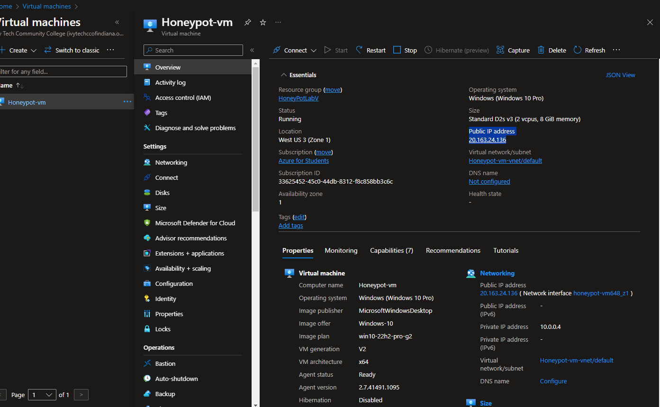

Since My VM is ready from my Home CPU, I opened Remote Desktop and take the copied IP address and paste address:

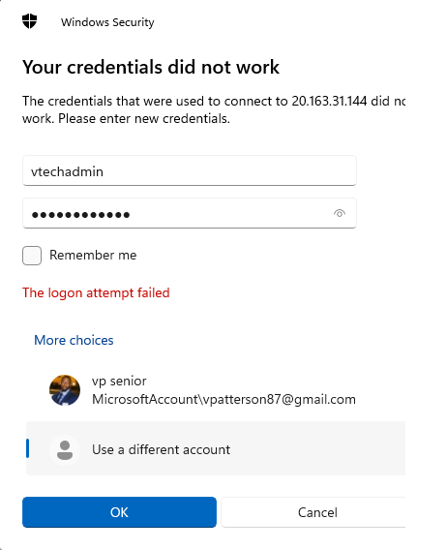

Accept the Certificate Warning:

After accepting you should have access to your desktop

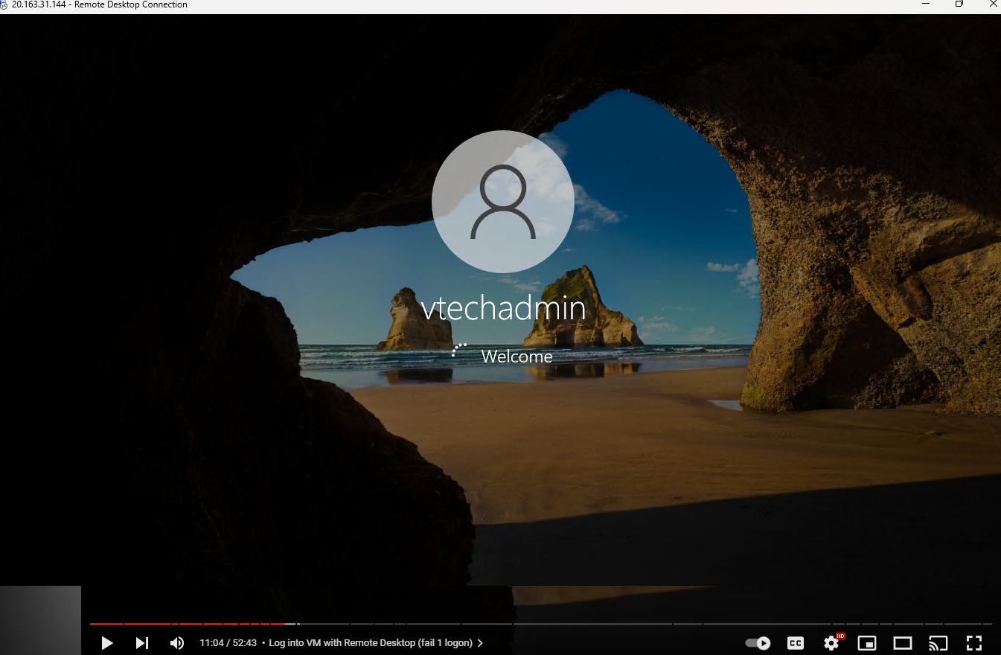

After my VM loaded decline all advertisement and features

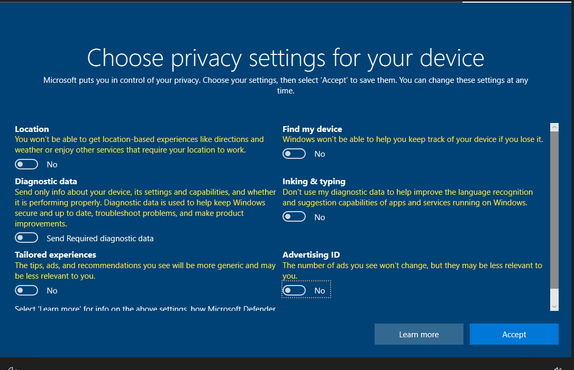

My remote Desktop was successfully created and now is running

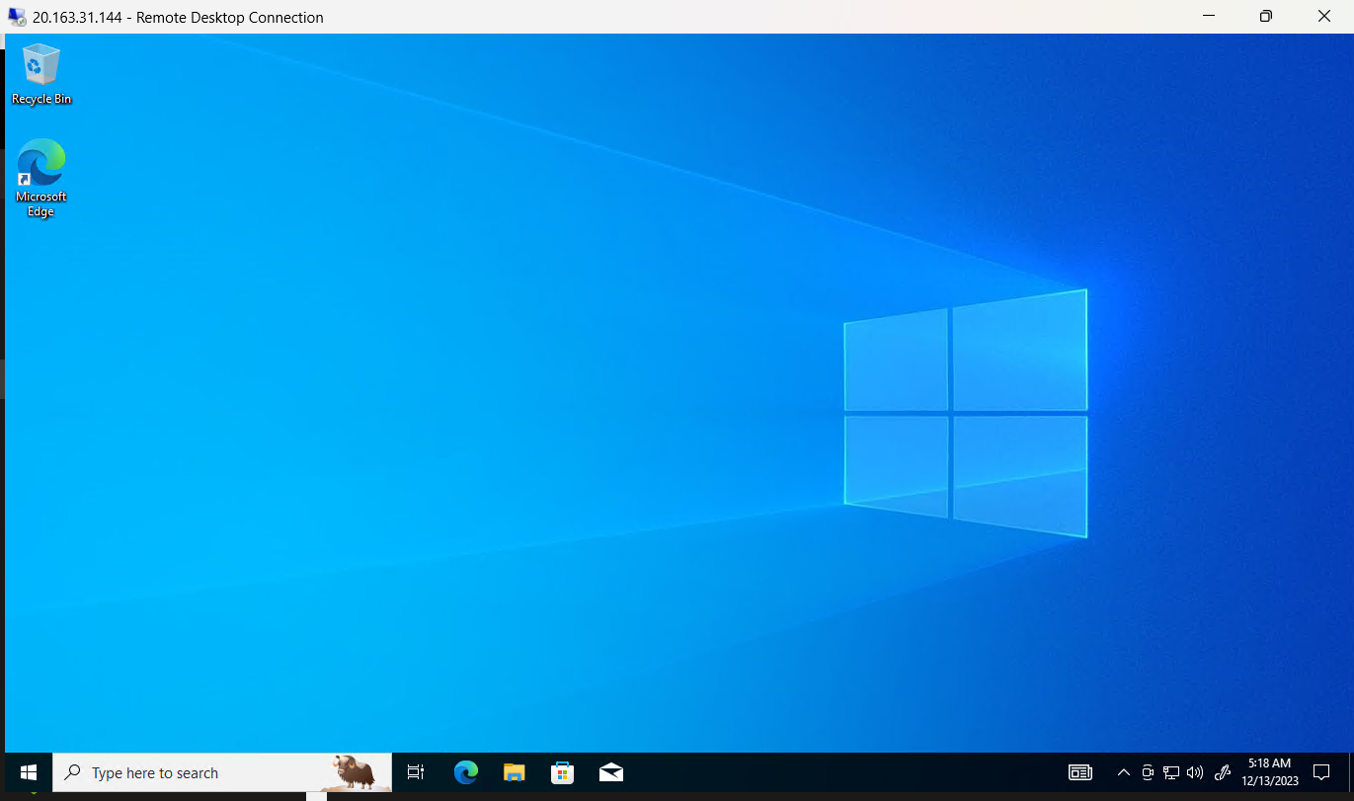

After creating my VM I also made sure to install Microsoft Edge, next I will be checking logs by going to the start menu “Event Viewer”

From Event Viewer>>Windows logs>>Security>>

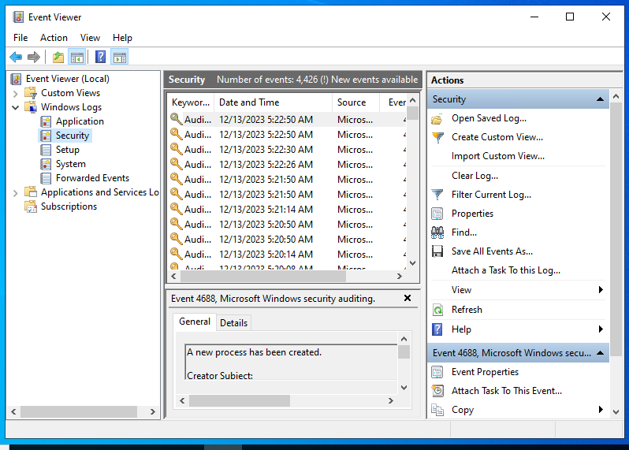

What I displayed was is showing all the security Events from my VM that I actually have however the security event I will be focusing on is event id‘’4625”. I will be gathering multiple failures of people to log into the vm through RDP.

Double Clicked on Event ID:4625

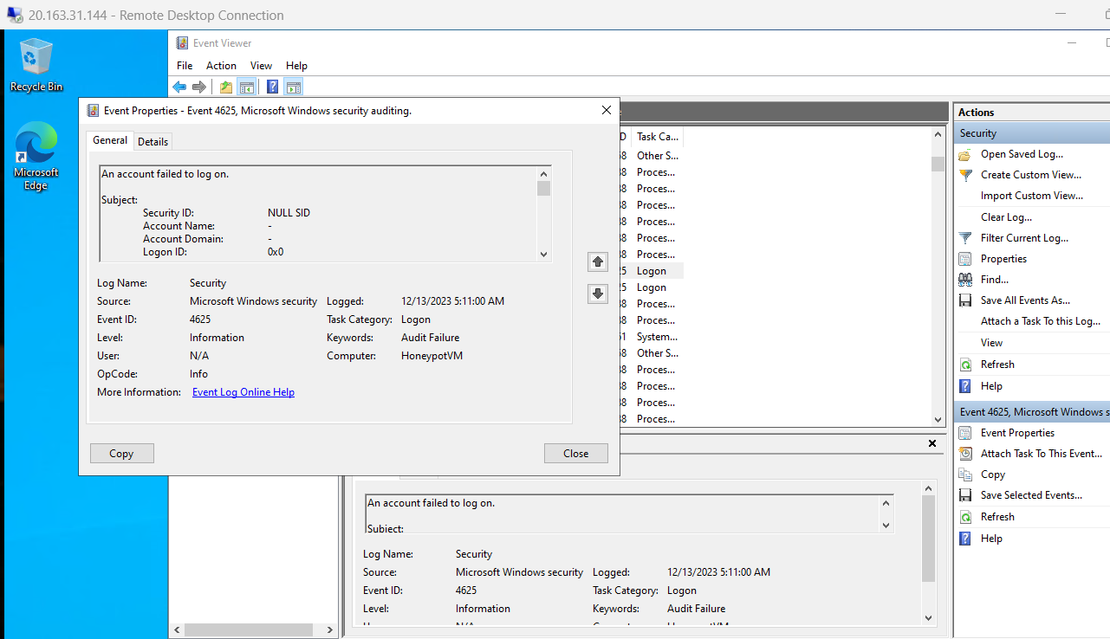

Expanding the Event id 4625 provided me details if their has been fail attempts however for this lab I have none. As shown. So I will create a failed attempt.

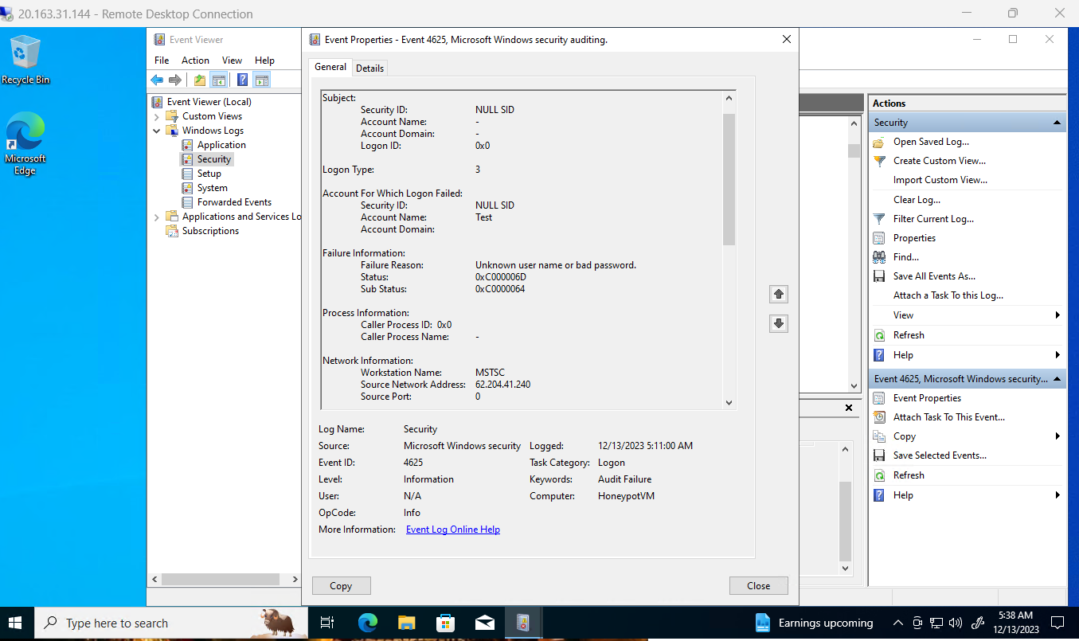

Failed attempts part 2.

Shows my attempt failed due to bad password. How checked this was remote a 2nd time from my home desktop and attempted to log in with my permission but gave it a bad password as example for this lab.

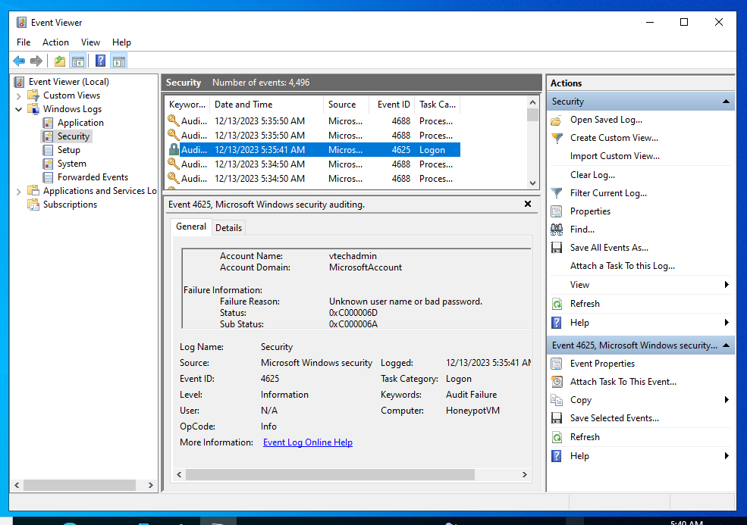

Within this failed attempt for lab purposes I will be using this failed attempt and utilized **Source Network Address: 76.84.135.36/.** People will start to discovering this on the internet. All ip addresses are goin to be here and there .

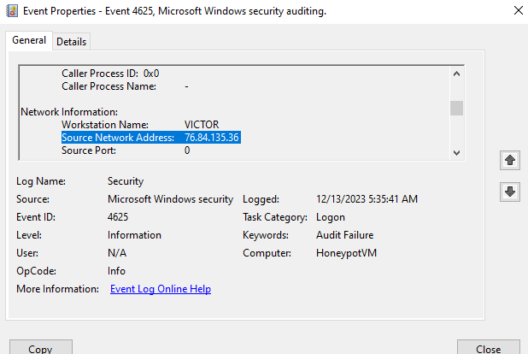

I will be using the IP address *76.84.135.36* and what I am doing is programmatically with PowerShell

Take this IP address and then use an ipg Location API.

<https://ipgeolocation.io/>

Paste IP address 76.84.135.36 to IP geolocation

Once performed I receive my coordinates

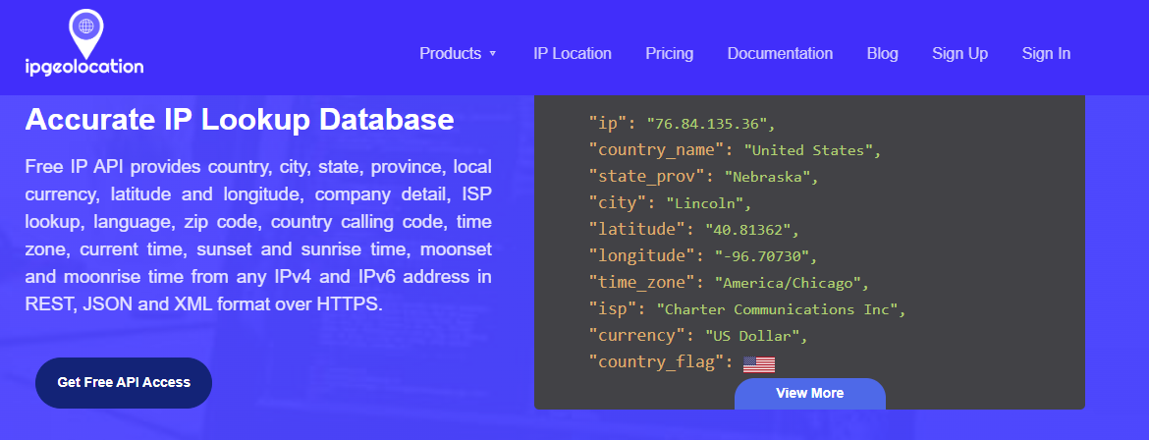

Next everything that was debefied in IP the IP GeolocationAPI. I will be creating my own custom log and then I will be sending that log to **log analytics workspace in azure and then I will be using Sentinel the sim to read the latitude & longitude or county and then kind of plot ;**

**Before doing this I went back to my VM and turn off the firewall**

**Typed “wf.msc” tp access my fire walls**

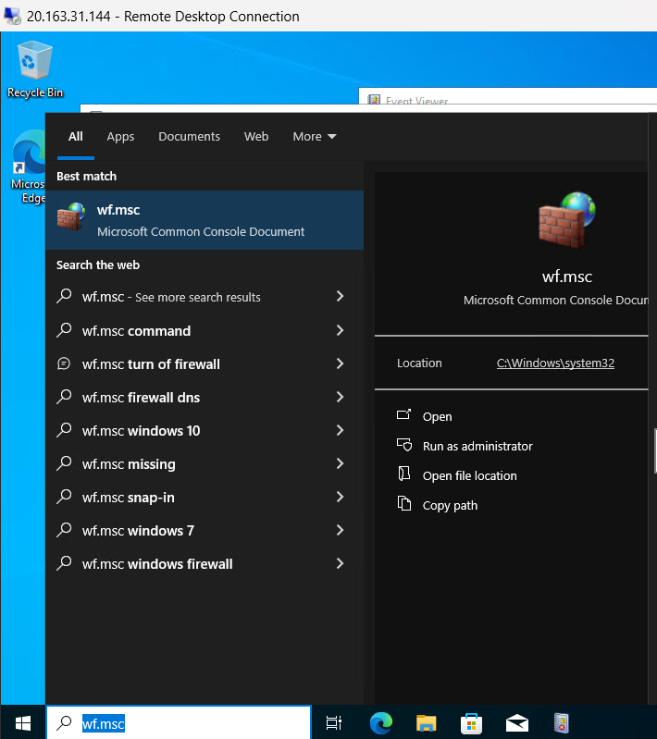

**Clicked on Windows Defender firewall to disconnect.**

**1st I opened cmd from Main Laptop**

**Ping** 76.84.135.36 -t for perpetual

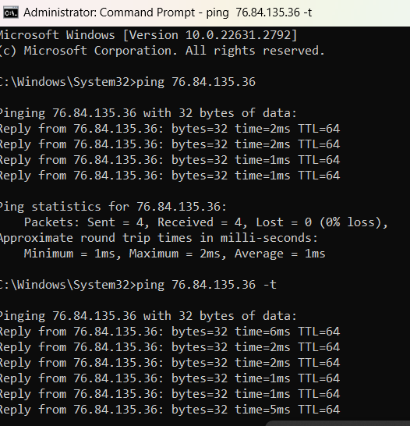

Next I wll be turning off my fire wall: by opening in my VM

**Start**>>> tryped **“wf.msc”>> click “Windows Defender Firewall Properties”** 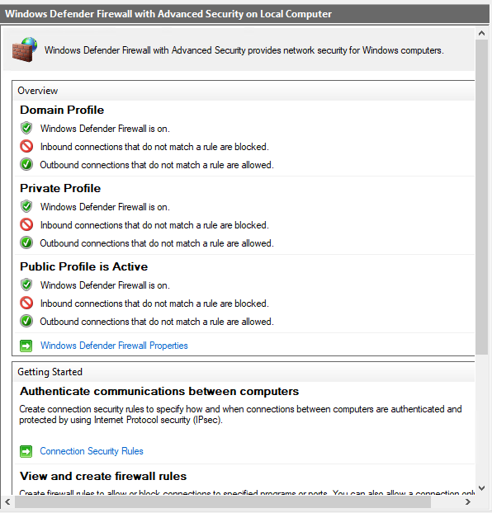

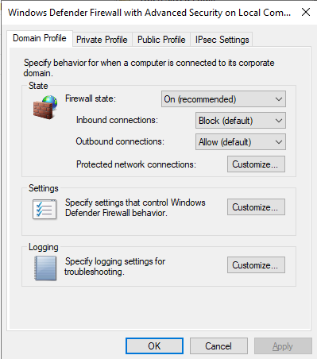

In the following tabs: Domain Profile, Private Profile & Public Profile, Turn off the Firewall State as shown below.

Domain Profile turn off:

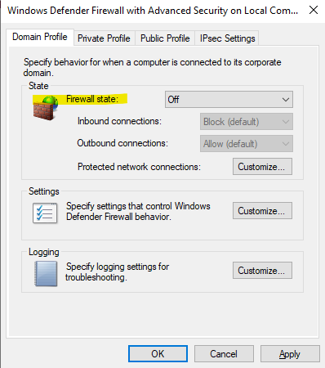

**Private Profile fire turn off:**

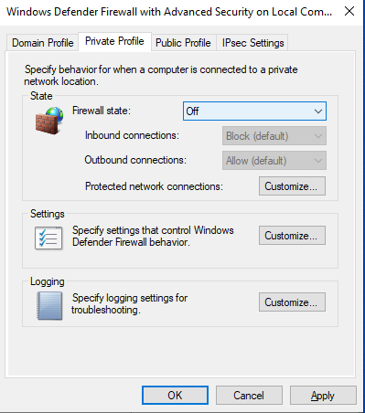

**Public Profile Turn off:**

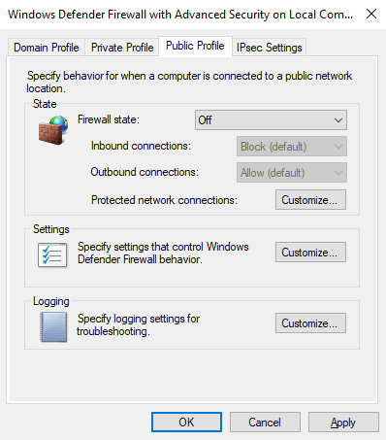

* + ***Note:***
  + Ignored the "SQL Server" plan because I am not running any SQL servers in this environment.
  + **Activate the selected plans to initiate data collection and aggregation.** This data will be crucial for later analysis in Azure Sentinel.
  + In order to set up Sentinel
  + Search bar type Sentinel
  + Once Displayed I created.
* **Benefits:**
  + Gain comprehensive visibility into your Azure environment's security posture.
  + Securely collect and aggregate data from your HoneyPot-VM, including log data and security events.
  + Prepare this data for seamless ingestion and analysis within Azure Sentinel
  + .

**Step 2: Connecting Your HoneyPot-VM to Microsoft Defender for Data Collection**

* **Locate your HoneyPot-VM within the Azure Portal.**
* **Navigate to the "Security" section and select "Security Center."**
* **Click on "Data connectors" and then "Add data connector."**
* **Choose "Azure Defender for Cloud" as the data connector.**
* **I Follow the on-screen instructions to configure the connection.** This typically involves providing authorization credentials and specifying the data sources to be collected.
* **Verify the connection status and ensure data collection is active.**

**Benefits:**

* I Establish a secure and reliable data flow from your HoneyPot-VM to Microsoft Defender for Cloud.
* I Ensure all relevant security events and logs are collected from your VM for comprehensive analysis.
* I Lay the groundwork for advanced threat detection and incident response capabilities in Azure Sentinel.

**Noteworthy Points:**

* I Enabling Foundational CSPM and Servers plans provides the minimum data collection necessary for basic security monitoring in Azure Sentinel.
* I also consider expanding my data collection based on my specific security needs and desired level of threat detection capabilities.
* I remembered to **verify the connection status** and ensure data collection is functioning properly before proceeding to further steps in your lab.
  + not running any SQL servers, so it doesn't need to be turned on. 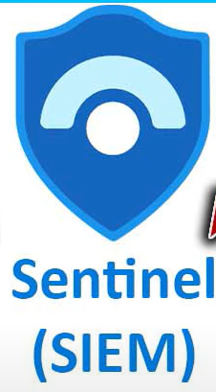

1. **Attack Visualization with Sentinel and PowerShell:**
   * **PowerShell Script:** I will develop a PowerShell script that extracts attacker IP addresses from Windows logs.
   * Script: 
   * This Script looks like this as shown but I also provided a copy of the script in my Project
   * 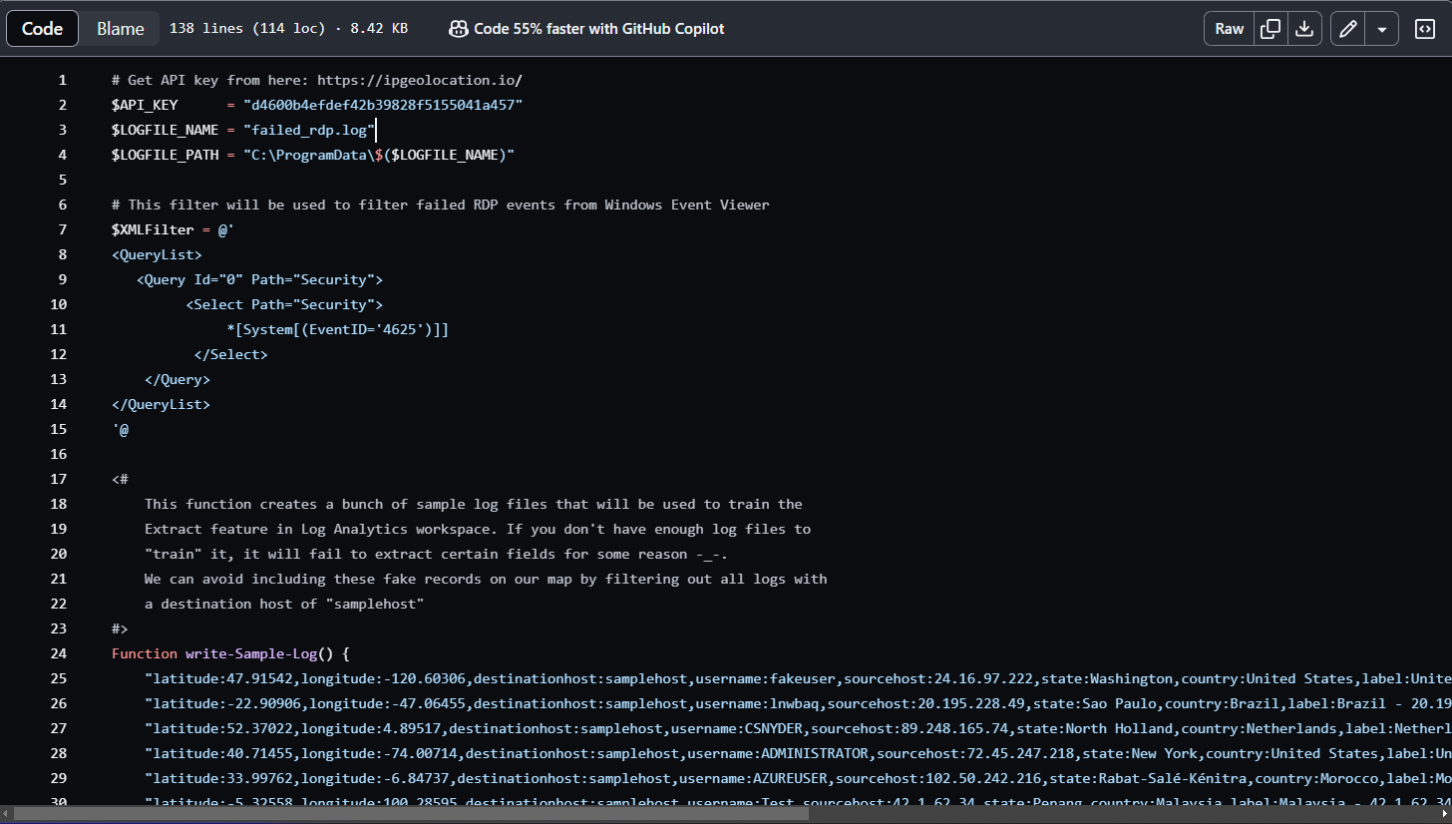
2. Next, I will open PowerShell ISE on my VM > New script.
3. 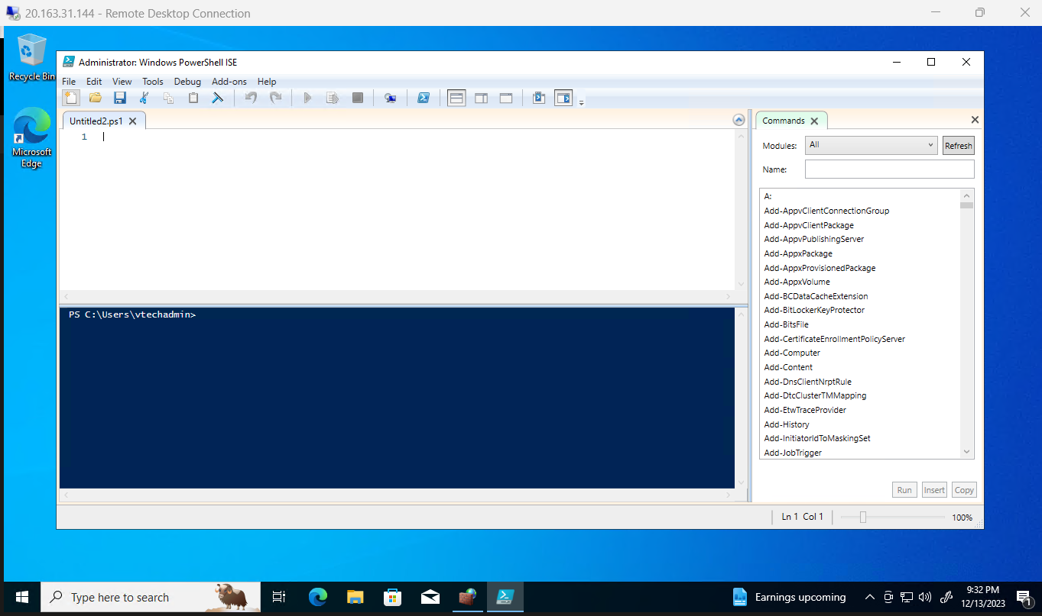
   * Paste My script:
   * 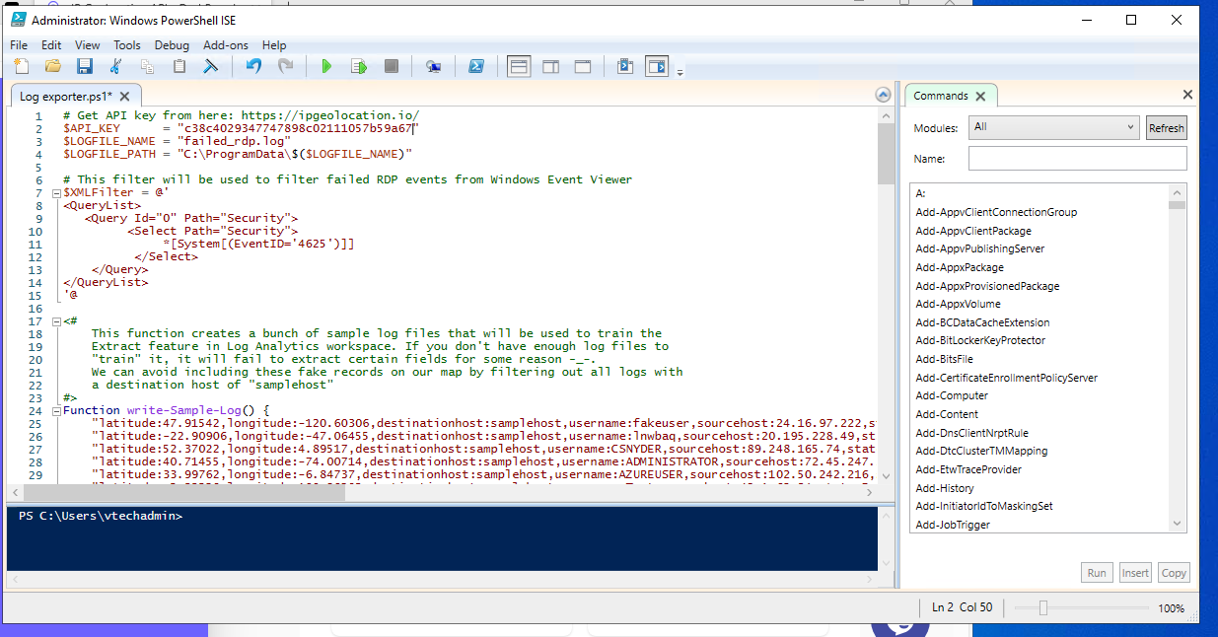
   * Save this file to Desktop as “Log exporter
   * Within this script I will go ahead and run this script. This script runs in “perpetuality” It performs a loop and essentially what it does is it looks through the “Event Viewer” which I remember the Event Views shows logs of failed login attempts. That I reviewed earlier in this lab.
   * ***Note***: The file C program data is a hidden folder and that was showing hidden so I will navigate to locate this folder manually.
   * 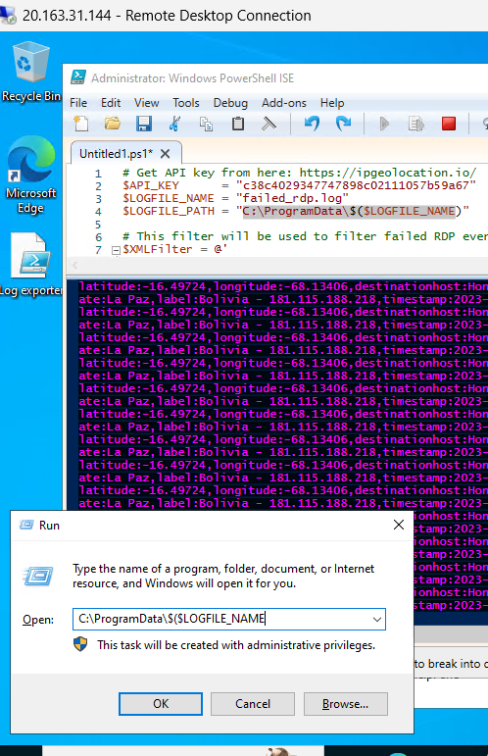

Locate the hidden folder but start>> Run> "C:\ProgramData\$($LOGFILE_NAME

* + If there is no log file, It will auto-create a default log file with sample records in it which I will use later to train log analytics workspace to accept and parse out our custom log.
  + 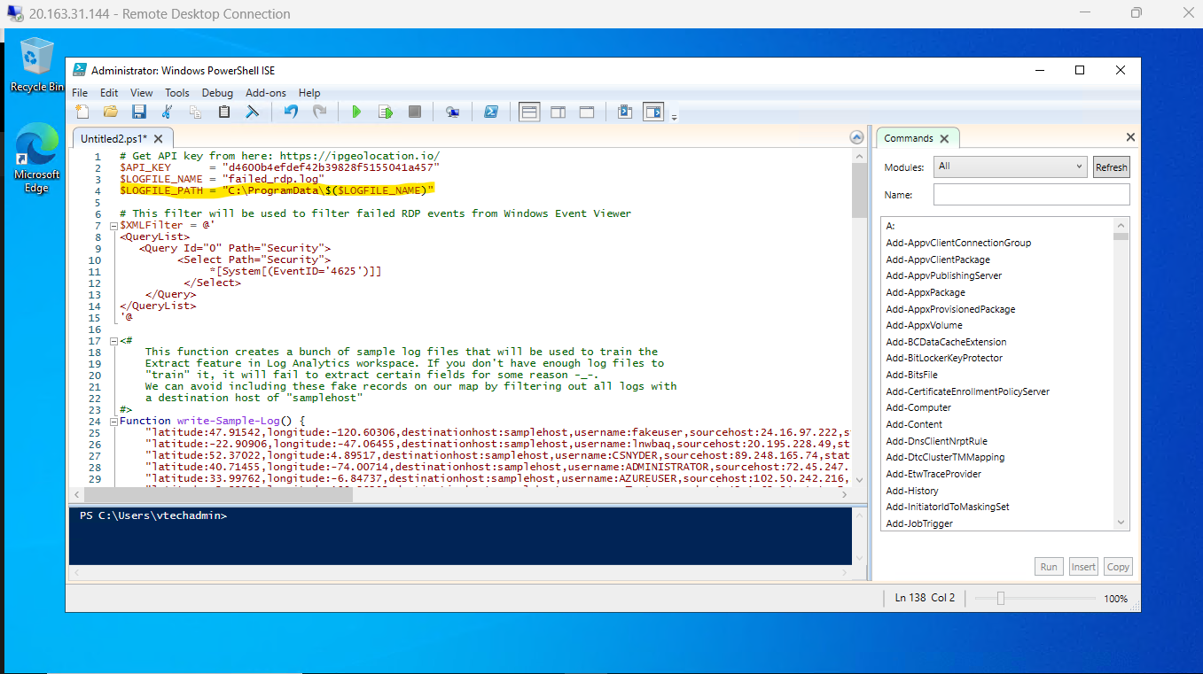
  + As the scripts runs, its providing the non failed-attempts but the purple is showing
  + 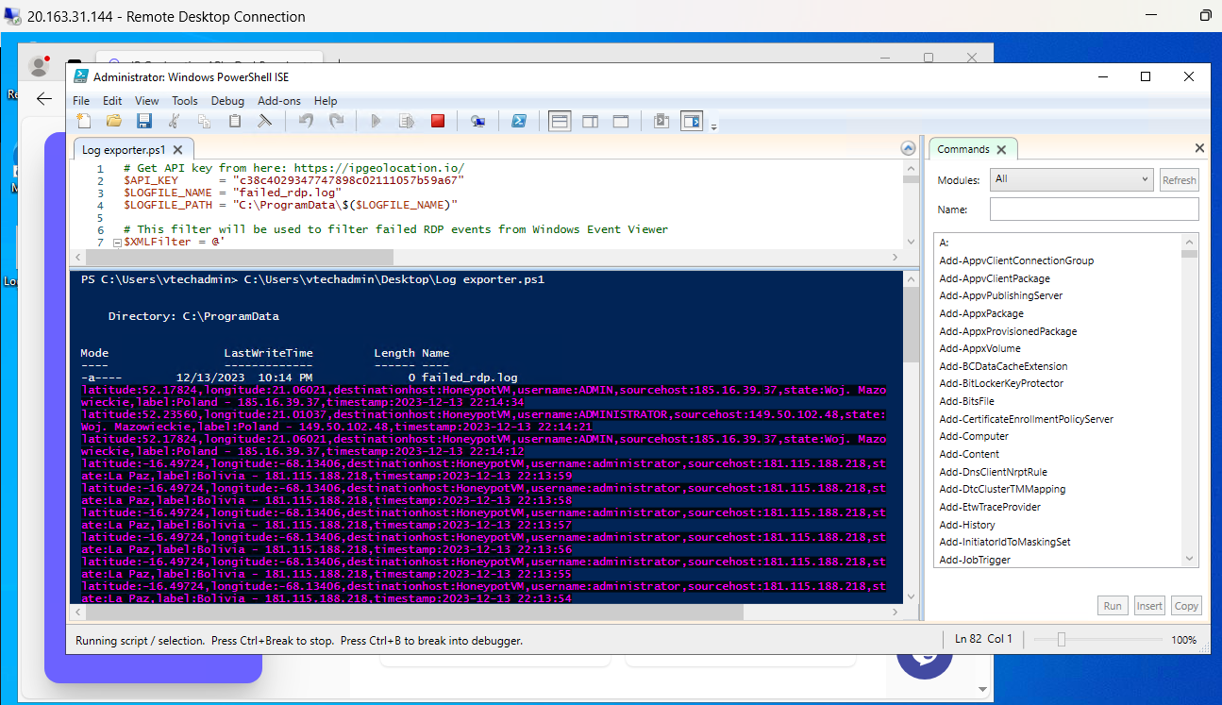

Next in my VM operating system I opened <https://ipgeolocation.io/> and created an acct to obtain my api Key

* + 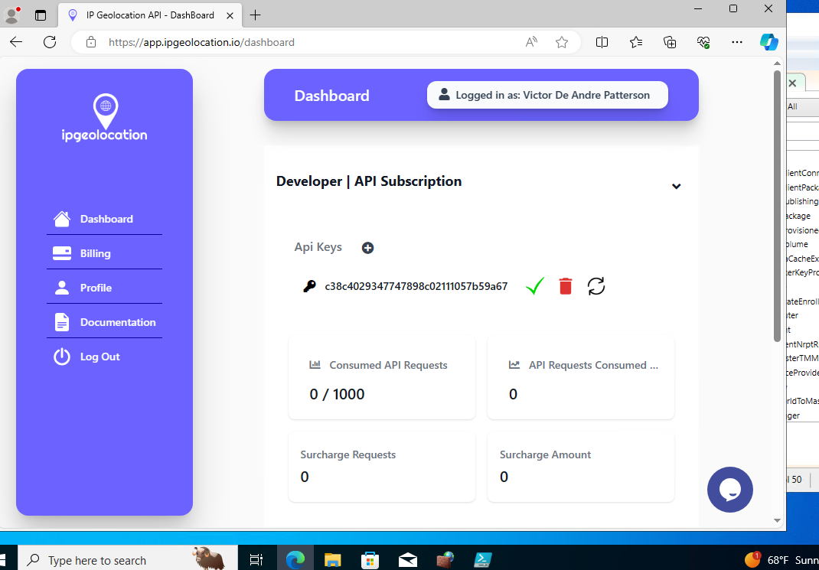
  + After obtaining my Api Key my next plan will be to
  + **Third-party API Integration:** The script will send extracted IP addresses to a geo-location API (e.g., IP2Location).
  + **Enriched Log Data:** The API will return latitude/longitude, city/state, and other geographical data for each IP address.
  + 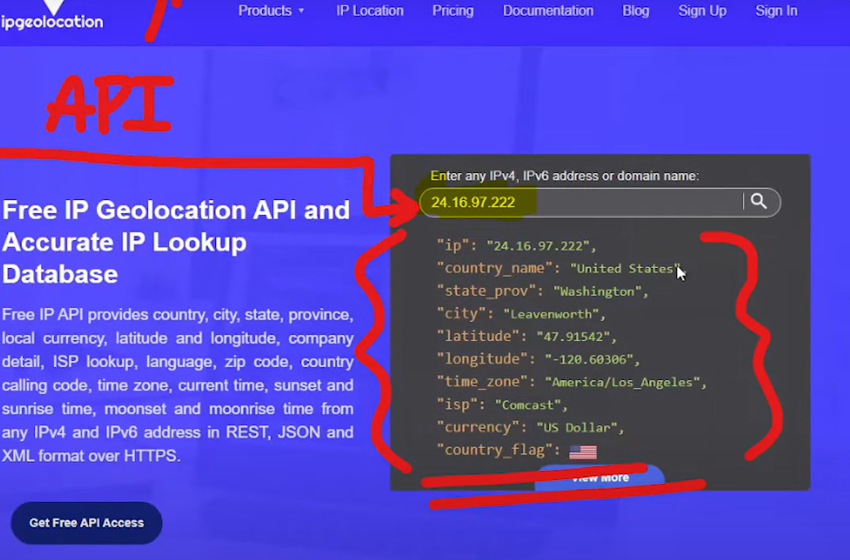
  + **Custom Log Creation:** I used the enriched data to create custom logs with geographical information.
  + NEW: This is the new path in order to create a custom log:
  + Open my Azure portal and traveled back to Log Analytics

1. Open the **Custom Log wizard** in the Azure portal by navigating to **Log Analytics workspaces > your workspace > Tables**.
2. Select **Create** and then **New custom log (MMA-based)**.
3. Define the **custom log table** by specifying the **log file** to be collected and the **criteria** for the log file.
4. Define the **custom log record properties** by specifying the **fields** to be extracted from the log file.
5. Save the custom log definition.

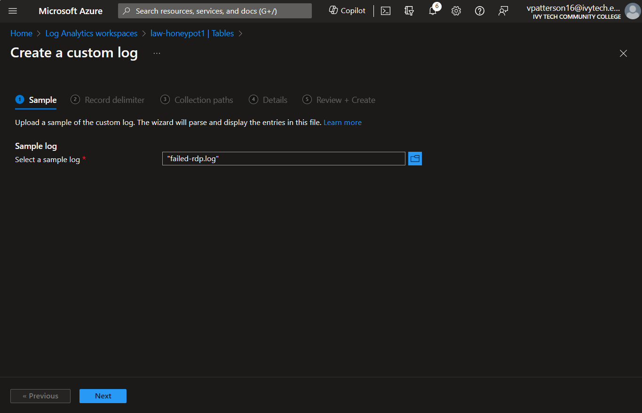

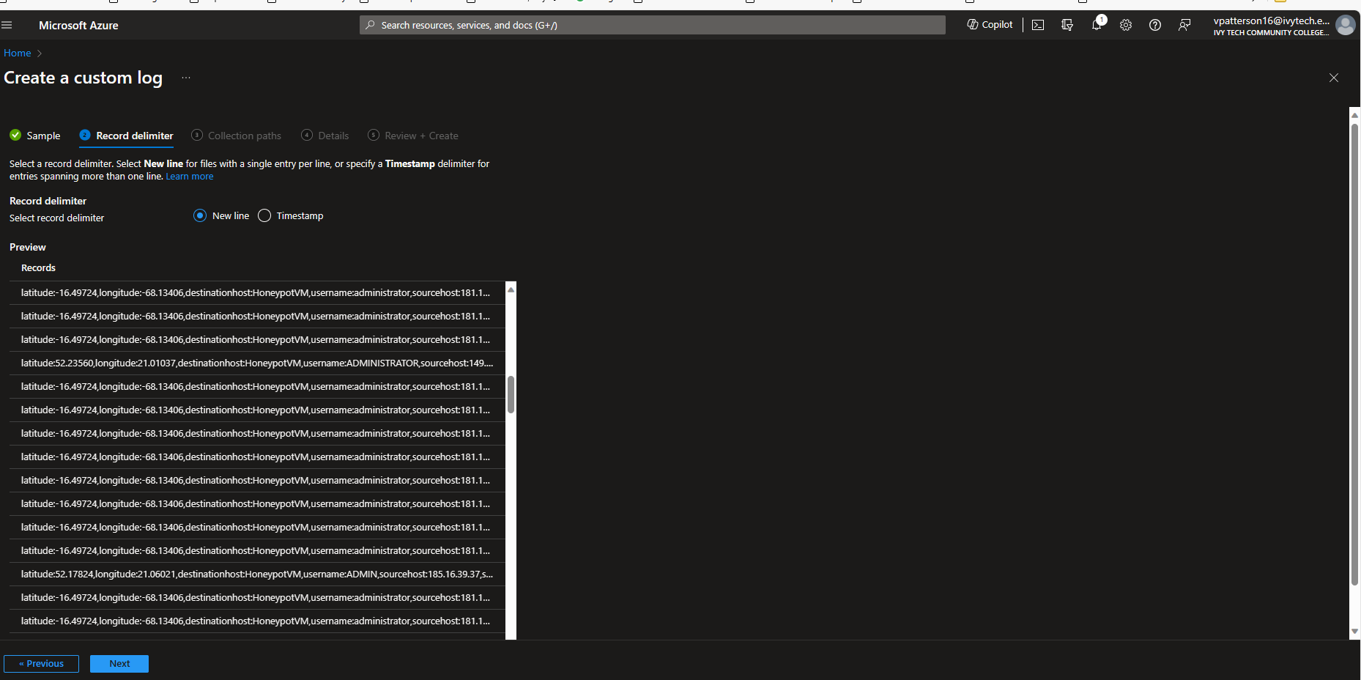

As I continued I was sure to add the Collection path by adding the Path from my VM. As shown below C:\ProgramData\failed_rdp.log

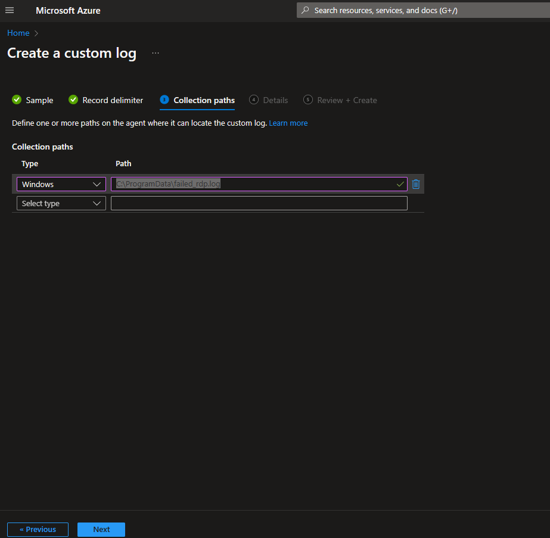

In the Details screen simply just created a custom log name FAILED_RDP_WITH_GEO

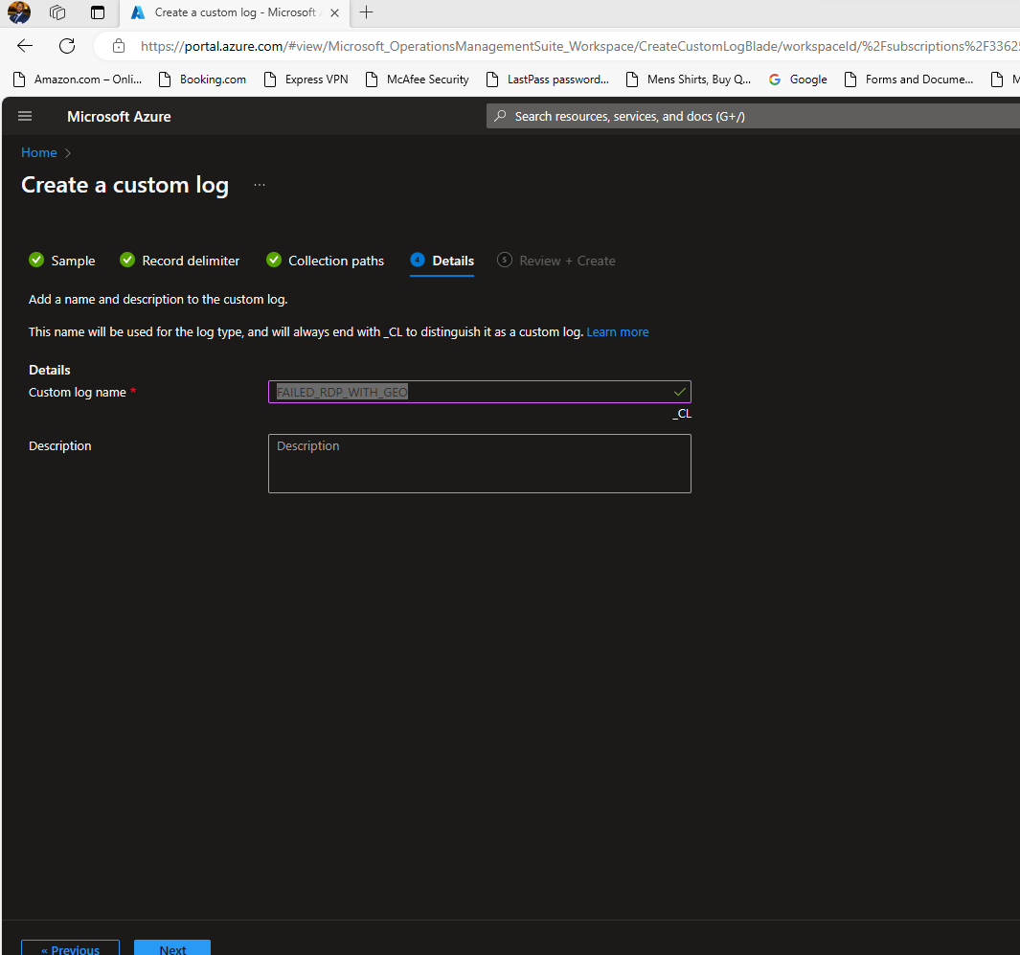

This will for the VM and Log Analytics to sink up to bring the log but I can still check it by showing a demo

* + 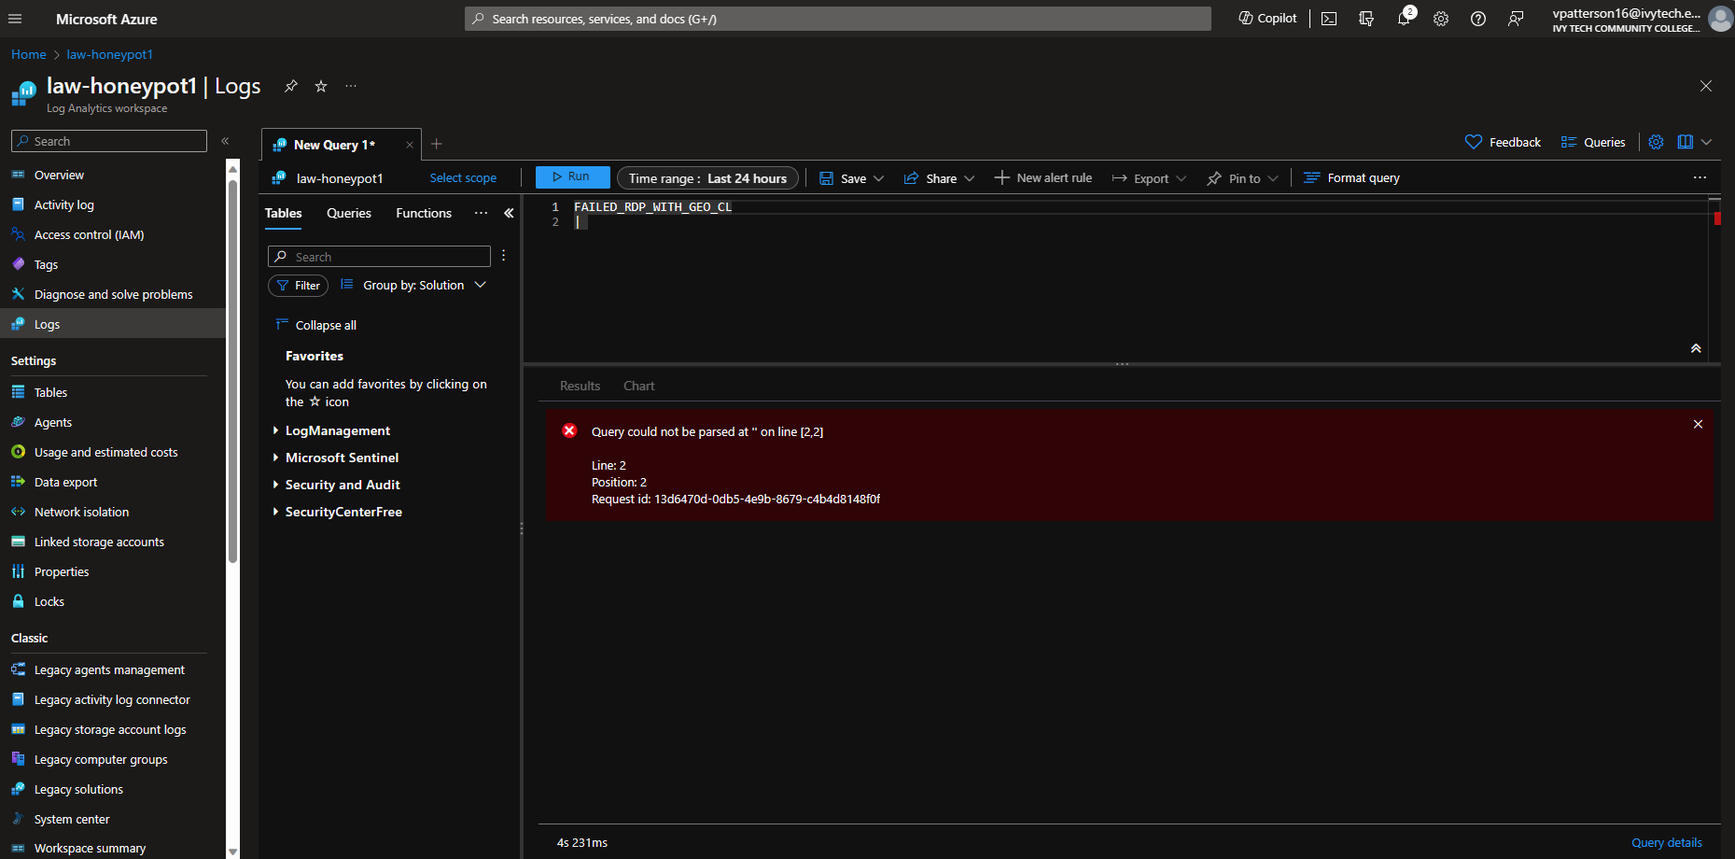
  + However I can check the **security event** by typing “**SecurityEvent**”>>**Run**
  + Security Event is the Windows event log from my vm as shown below which connects to the Azure work analytics workspace
  + Note: Make you delete line:2
  + 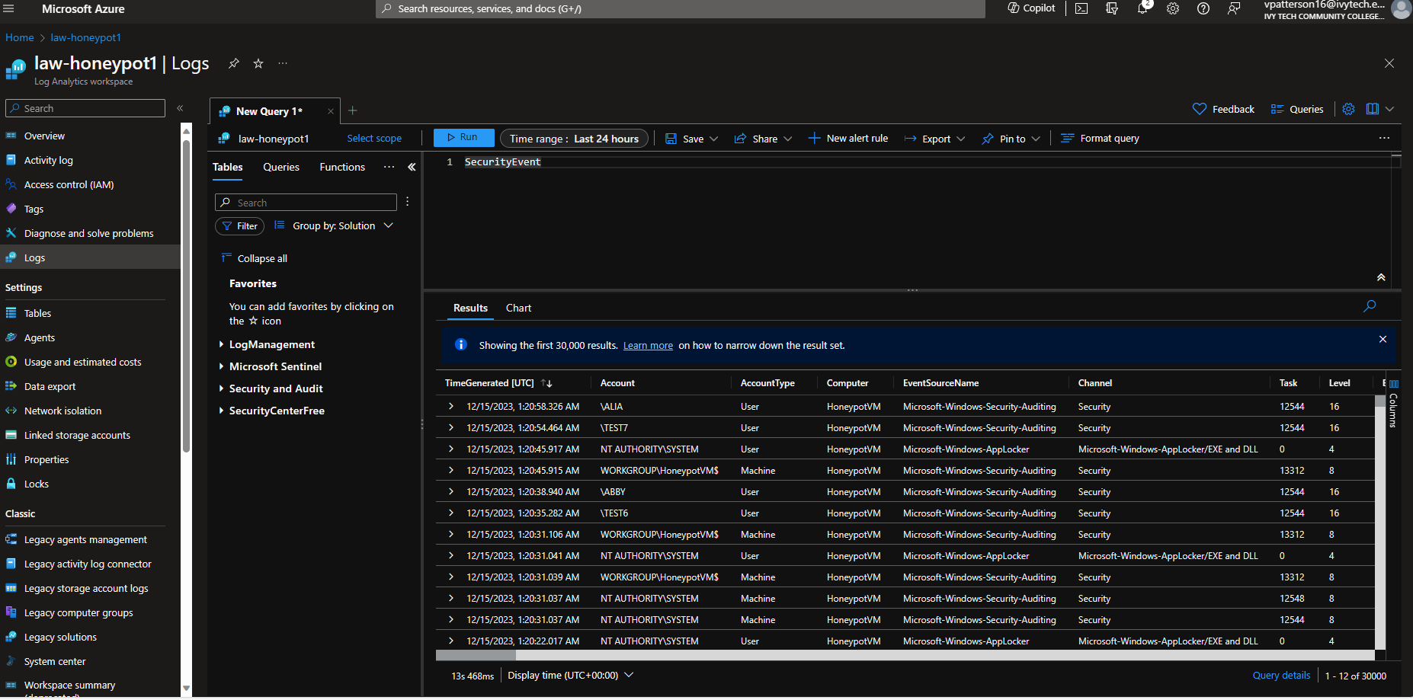 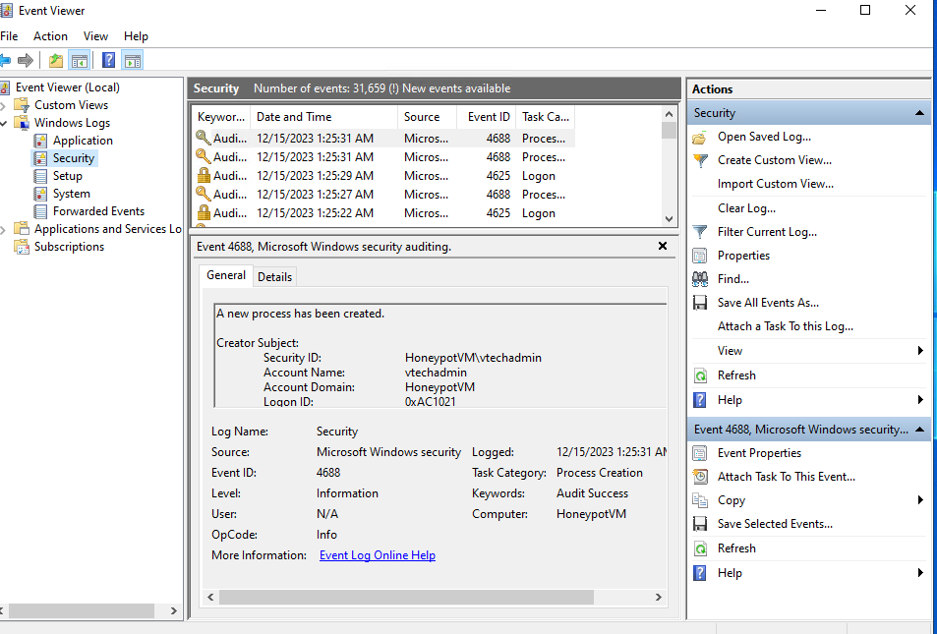

Now that I let some time past I ran Query **FAILED_RDP_WITH_GEO_CL >> RUN**

This screen shows random railed attempts that were logged into my system showing the other screen shows logs of failed rdp attempts and entries with the Latitude and longitude from previous information that was from my vm

* + 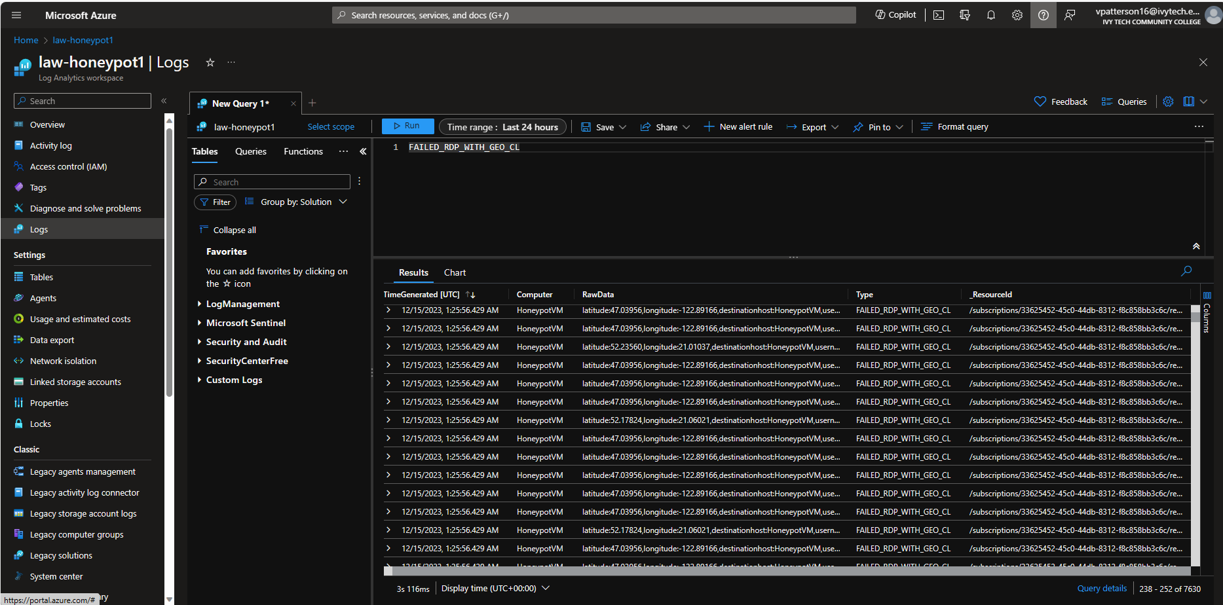 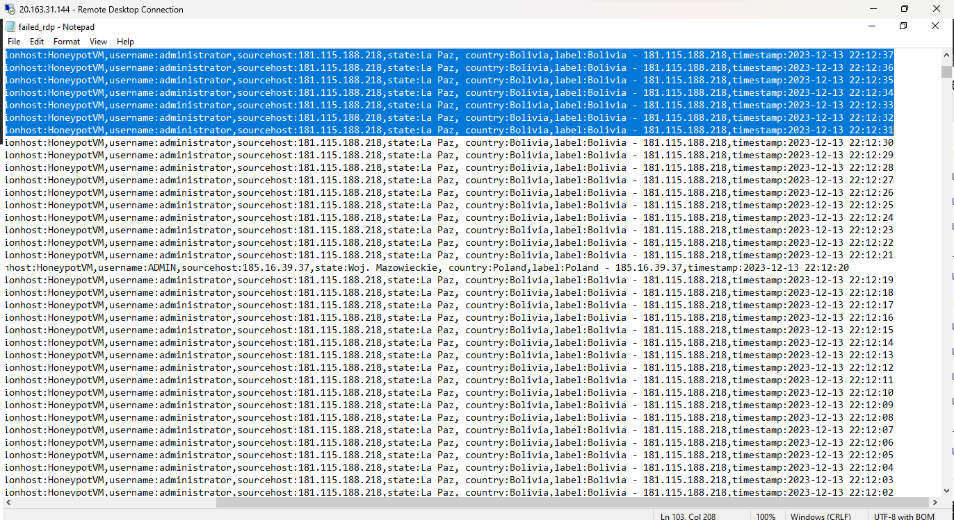
  + Next I will be taking the raw data and extracting certain fields from it. In order for me to do that I expanded a **log** >> **Click the three dots**>> **Click extract fields**.
  + **Sentinel Map Visualization:**
  + **First step Azure Sentinel>>** click **Law**-**honepot1>>**
  + 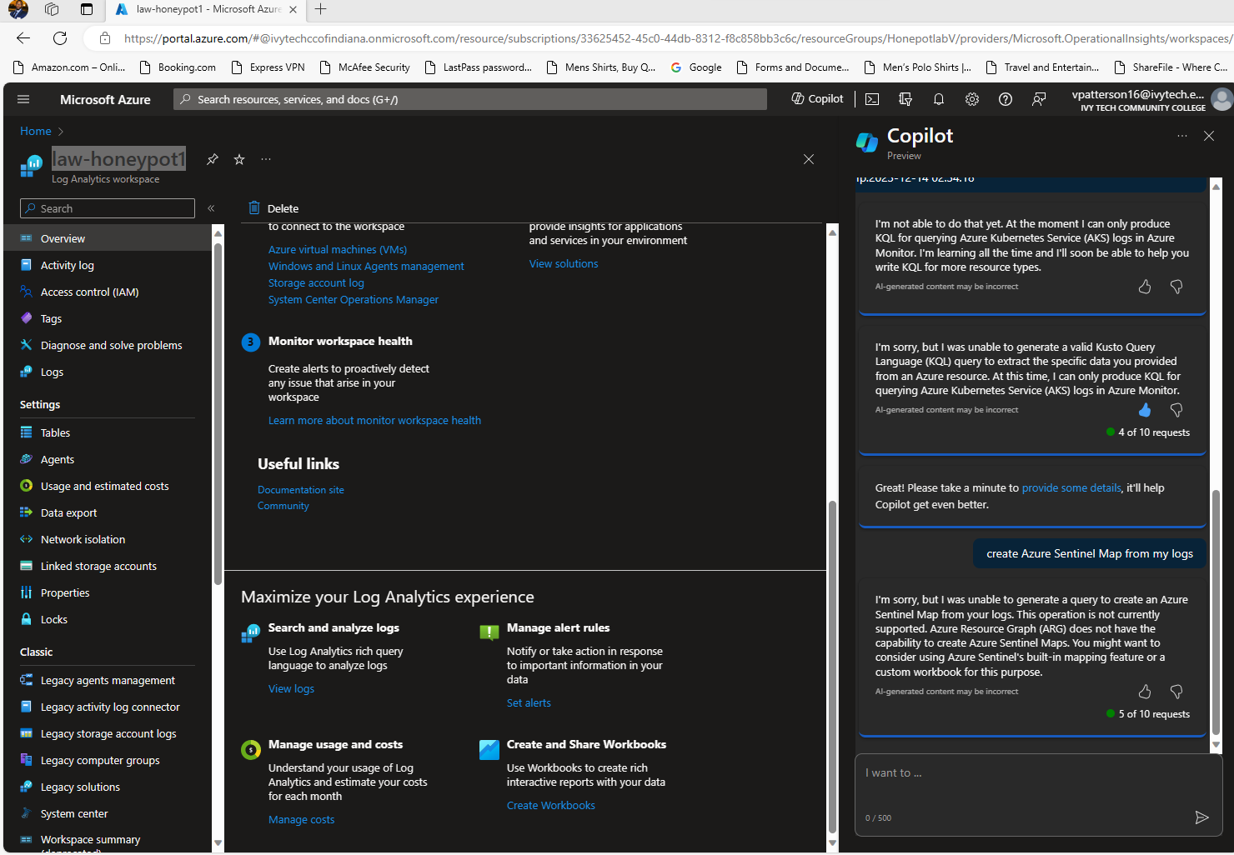
  + 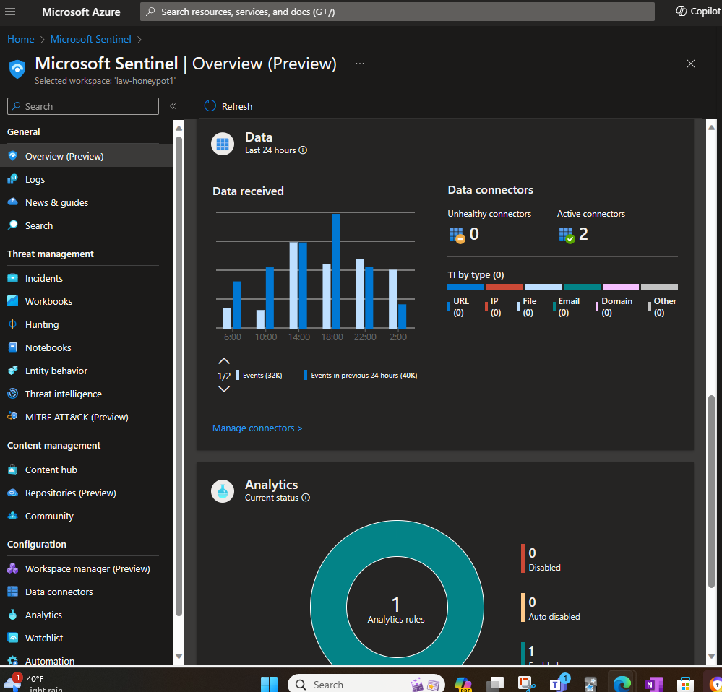
  + 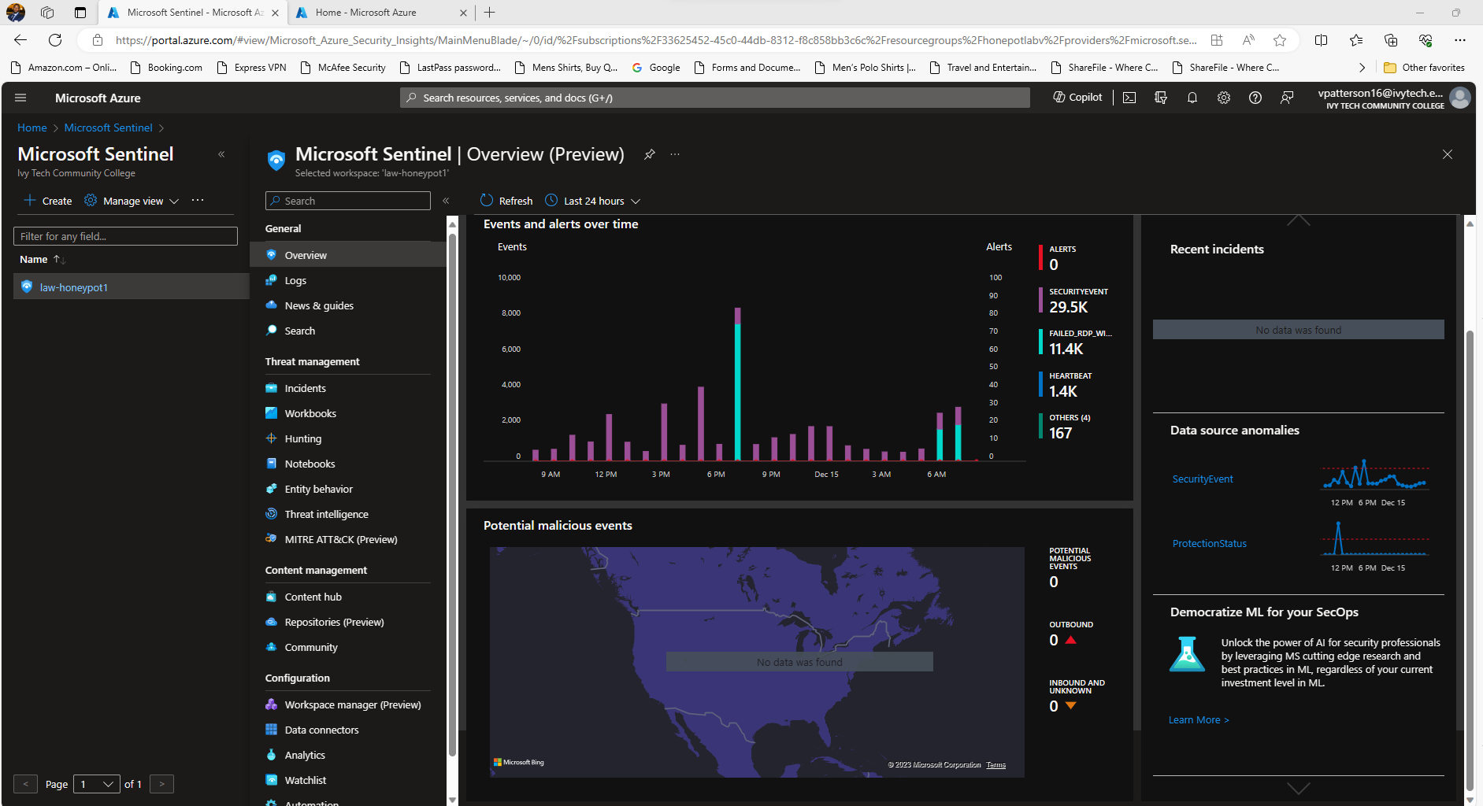
  + Next I will Click on the left hand column under **Threat Management Workbooks**>> “create new” >>and >>Click Edit
  + Removed Widgets on the right hand side
  + 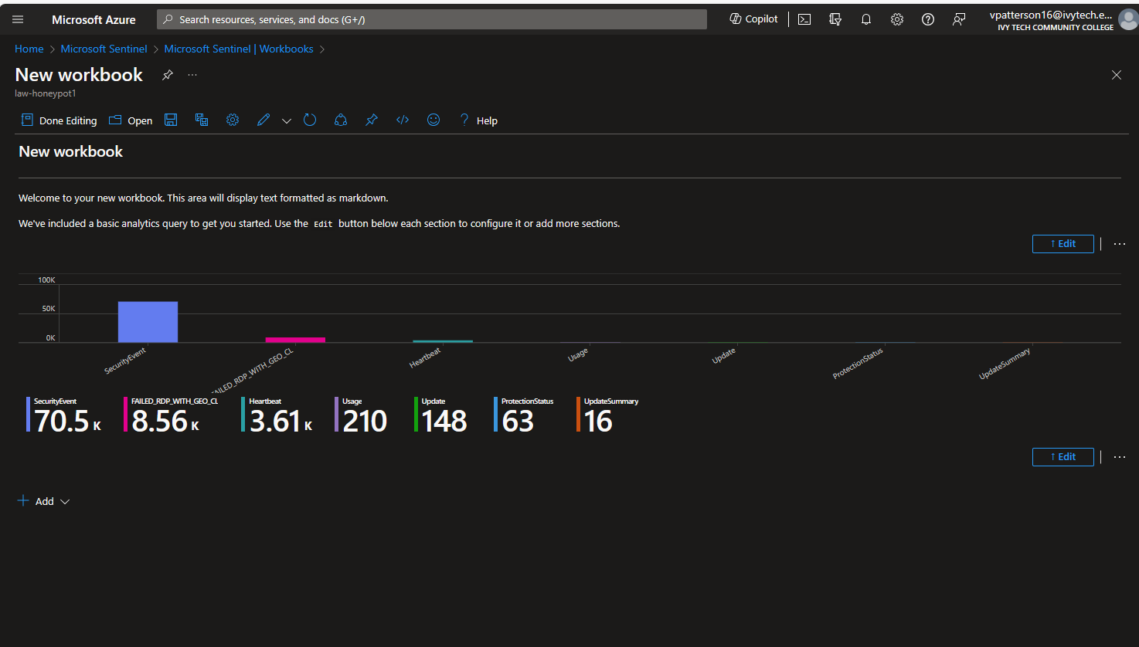 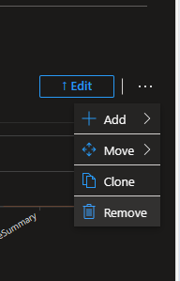
  + Next I will click>> “**Add**”>>click **Add Query**
  + 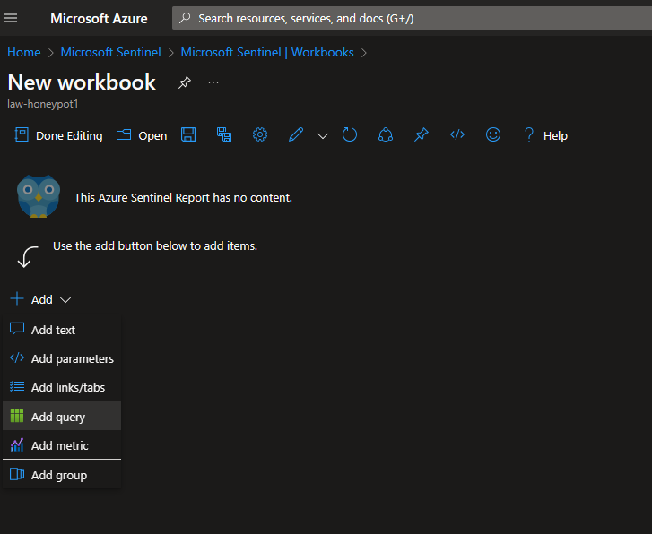
  + Once I was I was in my **ew Workbook** “Typed : **FAILED_RDP_WITH_GEO_CL**
  + | extend username = extract(@"username:([^,]+)", 1, RawData),
  + timestamp = extract(@"timestamp:([^,]+)", 1, RawData),
  + latitude = extract(@"latitude:([^,]+)", 1, RawData),
  + longitude = extract(@"longitude:([^,]+)", 1, RawData),
  + sourcehost = extract(@"sourcehost:([^,]+)", 1, RawData),
  + state = extract(@"state:([^,]+)", 1, RawData),
  + label = extract(@"label:([^,]+)", 1, RawData),
  + destination = extract(@"destinationhost:([^,]+)", 1, RawData),
  + country = extract(@"country:([^,]+)", 1, RawData)
  + | where destination != "samplehost"
  + | where sourcehost != ""
  + | summarize event_count=count() by latitude, longitude, sourcehost, label, destination, country
  + 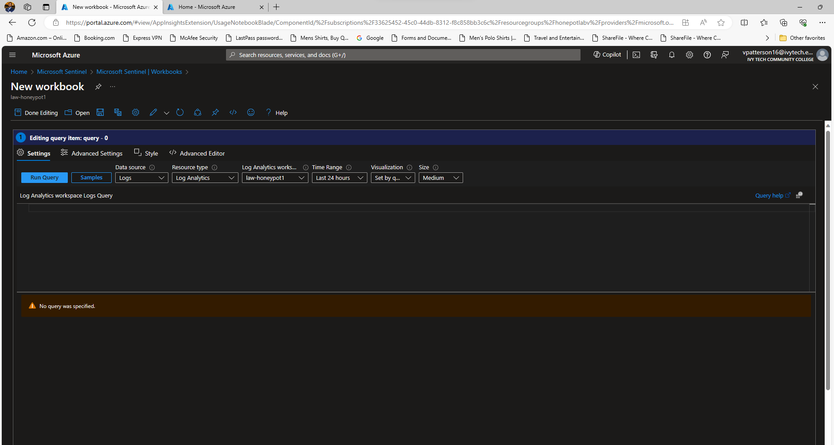
  + After running my query I have a nice layout of my data being extracted
  + 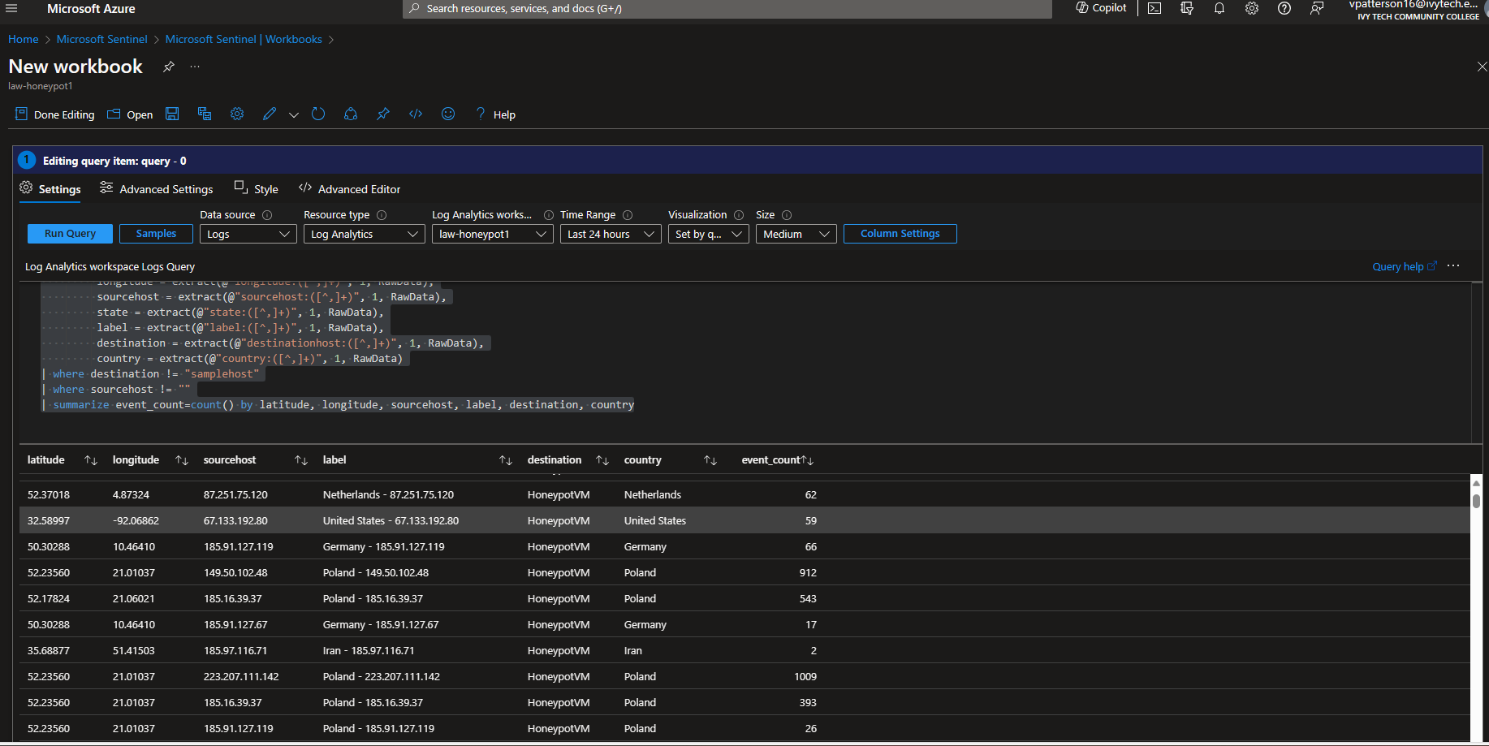
  + Finally, I populated an Azure Sentinel map with attack locations, providing a real-time view of global attack patterns.
  + 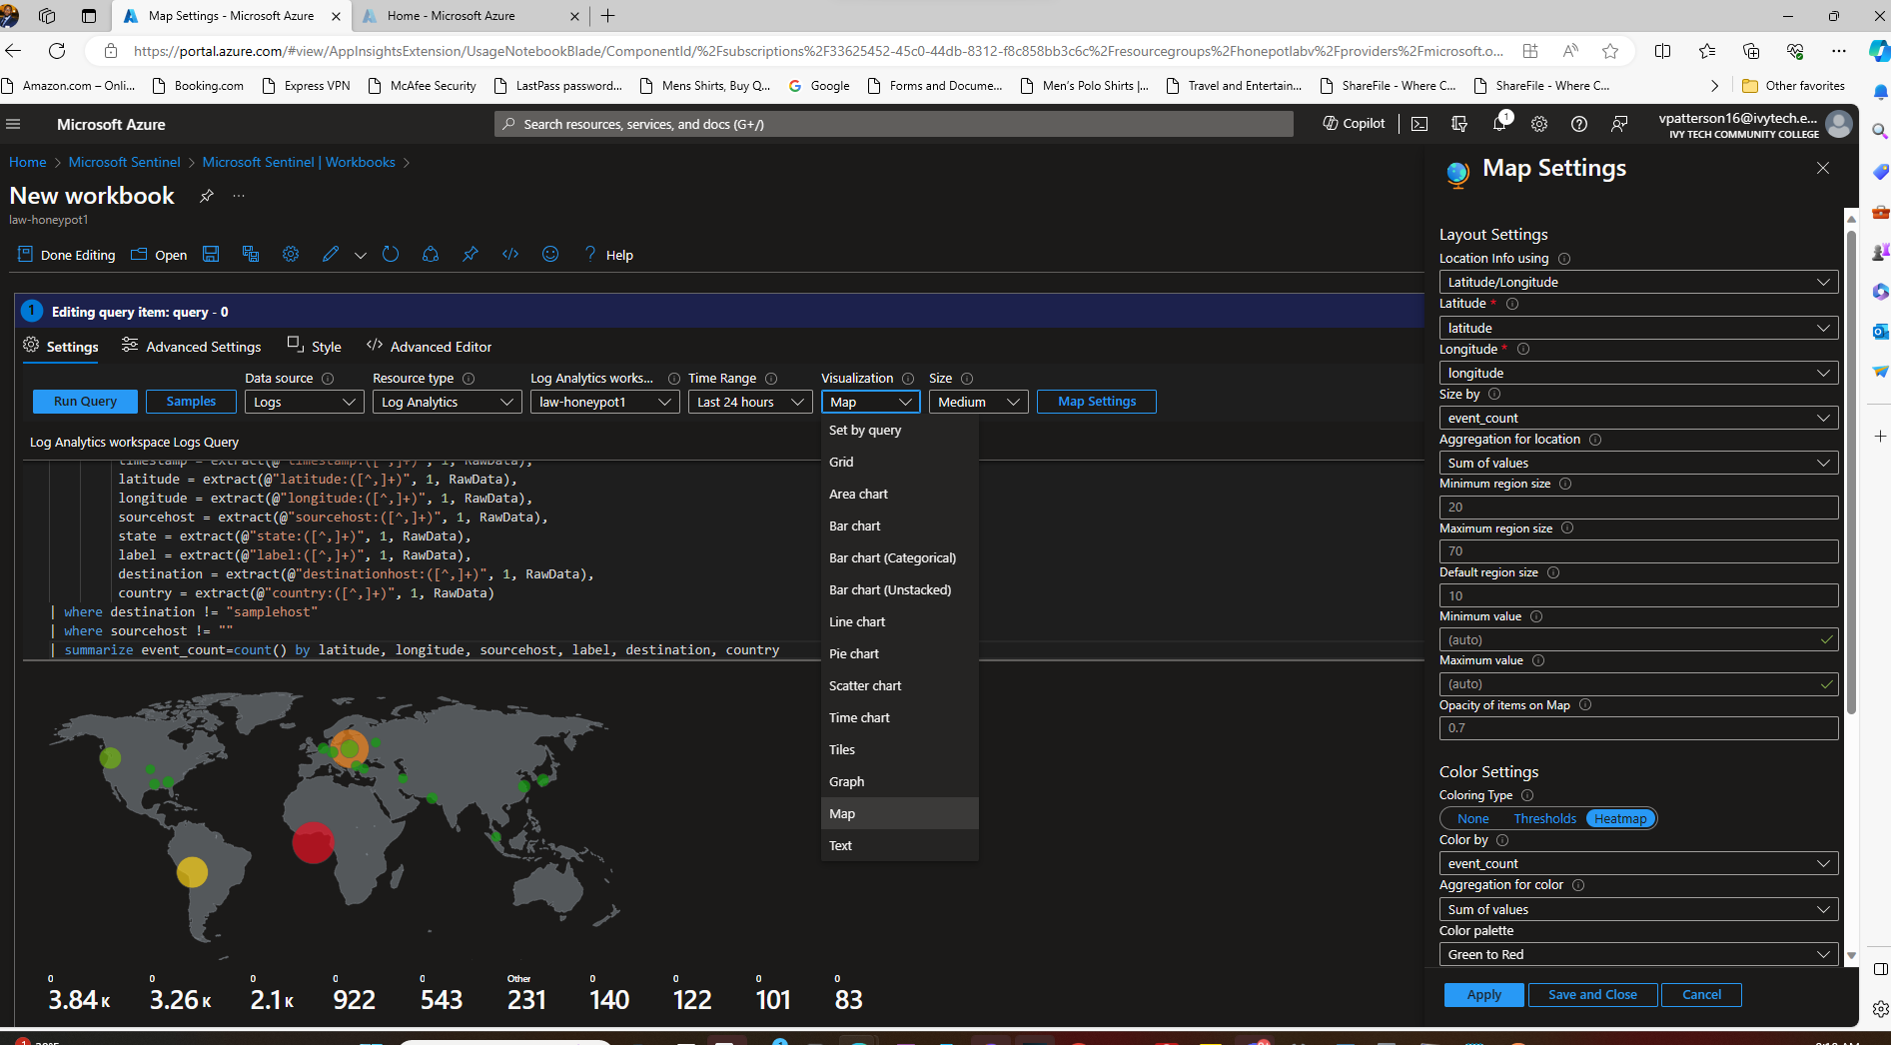

**Next I saved as Failed RDP World Map and I can Monitor the VM that shows live Cyber attacks.**

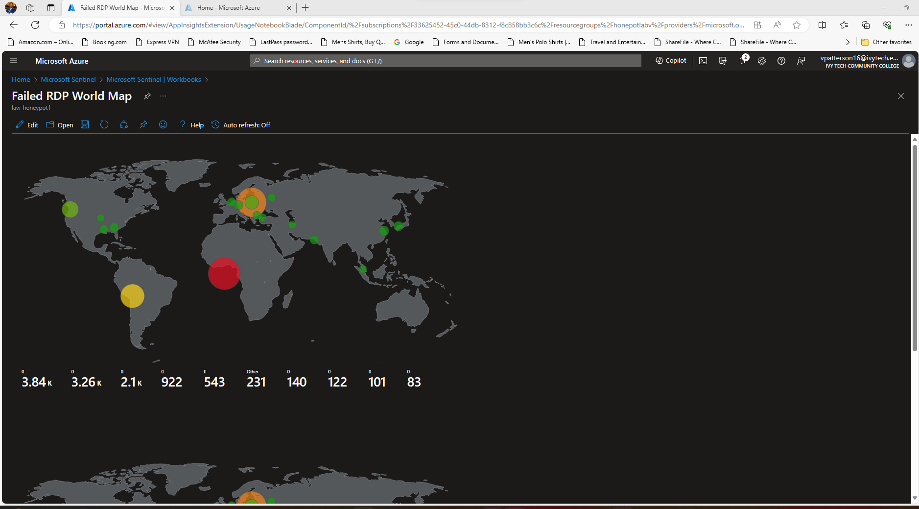

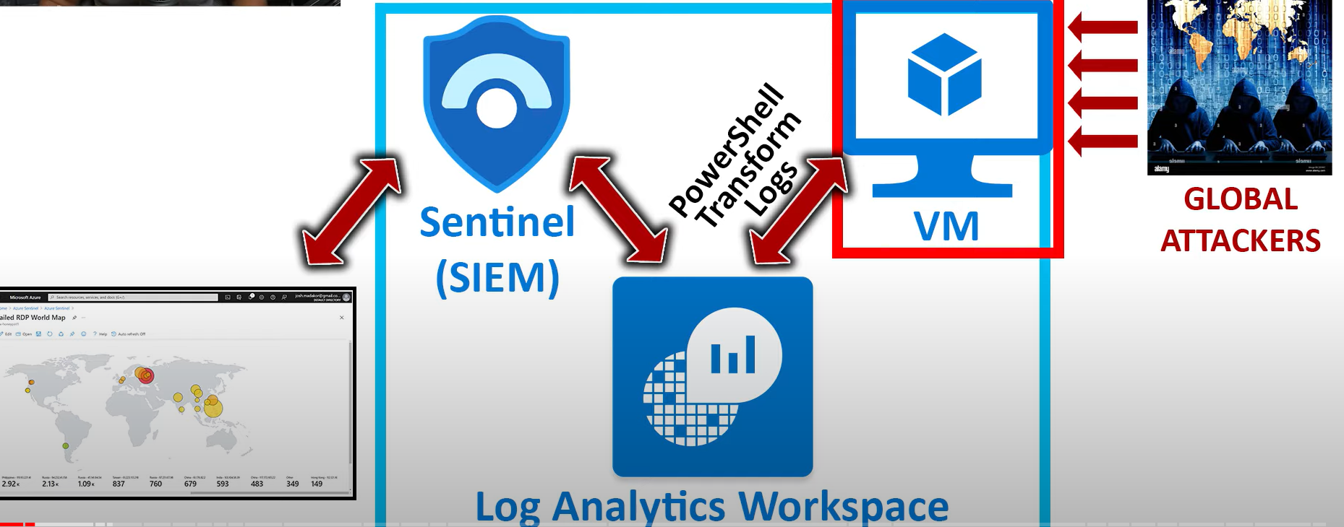

**Outcome:**

By the end of this lab, I have learned how to:

* Established a vulnerable VM to attract simulated attacks.
* Configured Azure Sentinel to ingest VM logs and gain insights into attack attempts.
* Developed a PowerShell script to extract IP addresses and enrich them with geo-location data.
* Visualized attack locations on an interactive Azure Sentinel map, gaining valuable insights into attack origins and patterns.

**Conclusion:**

This lab demonstrates the power of Azure Sentinel in analyzing and visualizing cyberattacks. By combining its capabilities with PowerShell scripting and geo-location APIs, we can gain valuable intelligence about attackers' origins and gain a deeper understanding of the global threat landscape.

**Technical Highlights:**

* Azure Sentinel's advanced log analytics and visualization capabilities.
* PowerShell scripting for log parsing and data extraction.
* Integration with third-party APIs for enhanced data enrichment.
* Creation of custom logs for improved data organization and analysis.

**Remember:** This lab is intended for educational purposes only. Never intentionally expose your systems to real-world attacks.

By: Victor Patterson Sr.